*July, 2012*

*Dear Cousins:*

*A few of us have been working to cobble together a brief history of the family, just in time for the 130th wedding anniversary of our ancestors George Moss and Emma Heyderman Moss*

*The families came from Germany (Heyderman) and Austria (Moss), arrived in the United States before the Civil War (during a time of great famine in Europe) and settled in the “Little Germany” of the Lower East Side of Manhattan (Heyderman); and (after traveling through the Midwest) in the “Little Germany” of Bushwick, Brooklyn (Moss). They were involved in making uniforms for the Union Army and the early diamond industry (Heyderman); and later the building of the Panama Canal, the manufacturing of sheriff’s badges and other Americana, and the early “hand-cancel stamps” used by the US Postal Service (Moss). A spectacular mother-daughter suicide from the Martha Washington hotel (Heyderman) was all over the tabloids in the early 20th century. And there’s more.*

*I’ve included a lot of hyper-links, and they’ll take you to some great pictures and additional information, although you may wish to skip them on your first read through.*

*So that we can keep in touch, here are e-mail addresses of George and Emma’s great-grandchildren:*

*Nathan’s children (family of Benjamin Franklin Moss)*

Bettina Moss:[*bettinamoss1@gmail.com*](mailto:bettinamoss1@gmail.com)

Selma Moss Ward: [*selma.mossward@gmail.com*](mailto:selma.mossward@gmail.com)

Michelle (Moss) Pizzo: 194 Lawrence Ave, S.I., NY 10310

Grace Moss-Beglane: 81 Roselle St. Mineola, NY 11501

Ben Moss: [*benjaminmoss@yahoo.com*](mailto:benjaminmoss@yahoo.com) 1712 E. Holly St, Brea, CA 92821, [714 869-6457](tel:714-869-6457)

Janine Moss: c/o Angela Moss - 61 Stonegate Dr. S.I., NY 10304

*George’s children (family of Benjamin Franklin Moss)*

Brette Faith Moss: (MD)

Jonny Moss: (NJ)

Floyd Moss: (deceased)

*Marjorie Moss Raphael’s children (family of Samuel H. Moss)*

Ron Raphael: No e-mail. 16 West 16th Street, NYC, NY 10011 (212) 989-0293

*Ira’s children (family of Adolph Moss):*

Steven Moss: [*samoss@optonline.net*](mailto:samoss@optonline.net)

Marje Sobylak: [*mas9258@nyp.org*](mailto:mas9258@nyp.org)

*Sandy’s children (family of Adolph Moss):*

David Moss: [*mosstel@earthlink.net*](mailto:mosstel@earthlink.net)

Larry Moss: [*lawrence.moss@gmail.com*](mailto:lawrence.moss@gmail.com)

*Roberta (Bobby)’s children (family of Adolph Moss):*

Ann Buffam: [*acbuffum57@vermontel.net*](mailto:acbuffum57@vermontel.net)

Janet Zinn: [*jczinn135@aol.com*](mailto:jczinn135@aol.com)

*Donald’s children (family of Ruth Moss Spanier):*

Bob Spanier: [*BSpan45@gmail.com*](https://webmail.c.earthlink.net/wam/ContactCategorySendmail?contactid=1645127409&x=-1480542864)

Rick Spanier: (AZ)

Karen Spanier: deceased

*Marcia’s children (family of Viola Moss Levinson):*

Mark Sameth: [*pcsyn@mindspring.com*](mailto:pcsyn@mindspring.com)

David Sameth: [*teledode@yahoo.com*](mailto:teledode@yahoo.com)

Ilene Sameth: [*Bustario@nyc.rr.com*](mailto:Bustario@nyc.rr.com)

The Ribets: David [Ribeti@aol.com](mailto:Ribeti@aol.com), Claudia [cribet@bariblaw.com](mailto:cribet@bariblaw.com), and Ken [ribet@math.berkeley.edu](mailto:ribet@math.berkeley.edu)

*Please note that this is still a work in progress. I’ve included almost nothing about the generation of George and Emma’s grandchildren (meaning our parents’ generation), or beyond. If you have more pictures or stories to contribute please share them (Ann has a lengthy memoir written by her mother Roberta “Bobby” Moss Zinn. Marje has letters her father Ira wrote her mother Doris during WWII. Rob has his father Donald’s diary from when he was a POW in a Nazi camp. I also understand there are movies of Benjamin Franklin Moss from the 1940’s.) It would be great to fill in the stories of the generations that came after the six Moss siblings, the children born to George and Emma Moss. Anyway, here’s their story.*

*Mark Sameth,*

*48 Fenwick Road*

*Hastings-on-Hudson, NY*

*10706*

[*pcsyn@mindspring.com*](mailto:pcsyn@mindspring.com)

The Family of George & Emma Moss

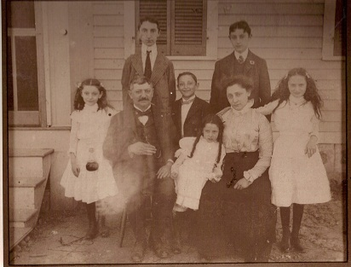

|  |
| --- |
|  |

*This picture is of George Moss and Emma Heyderman Moss, around 1901, with their children Benjamin Franklin, Adolph, and Samuel H (back row, left to right), and Ruth, Viola, and Irene (front row, left to right). The 1900 Census lists the family as living at 132 Eldert Lane, Brooklyn. That’s in the Bushwick section of Brooklyn, near the border with Queens. Perhaps that is the address of this picture. Or it might have been taken at a place in Connecticut the family was later known to go sometimes in the summer (called, Baumgarten's, it was a “farm holiday” resort; more below). As for the Heyderman name, Marcia Levinson Sameth tells us it was pronounced HIGH-der-man, with a long* i.*)*

THE EARLY 1800’s………………………………………………………………..……...page 5

THE MID 1800’s………………………………………………………………..………...page 10

THE LATE 1800’s………………………………………………………………..………page 20

TURN OF THE CENTURY………………………………………………………………page 30

THE TEENS ………………………………………………………………………….…..page 37

THE ROARING TWENTIES……………………………………………………………page 45

THE GREAT DEPRESSION…………………………………………………………….page 53

THE 1940’s AND BEYOND………………………………….……………………….…page 60

The Early 1800’s

Our family has been in the United States a *long* time, certainly longer than I ever realized. Both George and Emma were born here, years before the influx of Jewish immigrants. Indeed, George and Emma’s grandson Nathan Moss (b. 1927) told me that his father Benjamin Franklin Moss had told him that he had heard that his father George’s father Benjamin had come to the United States from England in the 1820’s (although that seems a little early as Benjamin’s wife was born in 1836; perhaps it was someone a generation earlier who had come in the 1820’s.) In any event, the family was certainly here by the mid-1800’s. So let’s start with a little background on Germany in that period.

In the 1850's nearly 1 million Germans immigrated to the United States, most of them small farmers and their families leaving southwestern Germany. Soon after, artisans and manufacturers left the central states of Germany. The German economy was suffering. And in 1840 rural Germany was struck by the potato blight which led to famine. During several of the immigration waves, young men emigrated to escape being conscripted in the German (Prussian) military service.

Most German immigrants to the United States settled in rural areas. The north-central states (Wisconsin, Minnesota and Michigan) promoted their states for settlement among Germans with funding and support from their state legislatures. So it’s no surprise that we find the Mosses in Ohio and elsewhere in the Midwest. Still, by 1875 German-Americans made up 75 % of New York City's population. From 1850-1870 German was the most widely used language in the United States after English.

Germany was not unified as a nation until 1871. Up to that time it was made up of multitude of states, princedoms, dukedoms, city states, etc. All of these diverse regions had their own dialects, customs and dress. The "Germans" who came to America in the 1800s tended to form communities within their own regional groups. Bavarians and Prussians were the two biggest German speaking groups who settled in New York City. (You can read more on-line [here](http://maggieblanck.com/NewYork/LowerEastSide.html), and at the Appendix)

An extensive collection of pictures of and essays about the German Lower East Side is online [here.](http://maggieblanck.com/NewYork/LowerEastSide.html) Note the casual anti-Semitism of "Lights and Shadows of New York Life: or, the Sights and Sensations of the Great City" by James Dabney McCabe, 1872 (and of *King's Handbook of New York City,* 1892.)

And now here are some links that give us a flavor of the world back in those days:

The [first photograph](http://www.youtube.com/watch?v=XW5QocpVkAU&feature=related) ever taken dates to 1826. Here is a collection of some of the earliest [photographs](Earliest%20photographs%20http:/www.youtube.com/watch?v=3LkaFCa29mQ&feature=related) ever taken. I found this [picture](http://www.transitmuseumeducation.org/trc/background) of early public transportation in New York City fascinating. It’s a picture of an “Omnibus” – an oversized horse-drawn carriage that could fit fifteen people. (The photograph comes to us from [H.T. Anthony and Sons](http://home.centurytel.net/s3dcor/Lewis/Lewis.htm), whose studios and offices were located at 501 Broadway. You can read more [here.](http://www.historiccamera.com/cgi-bin/librarium/pm.cgi?action=display&login=anthonyco) And for more on the omnibus click [here](http://www.openlettersmonthly.com/whitmanblog/2010/01/omnibus-jaunts-and-drivers/), [here](http://www.transitmuseumeducation.org/images/vocab/omnibus.html), and [here.)](http://www.imagekind.com/On-the-Omnibus--by-Maurice-Delondre-art?IMID=1da35475-f359-4796-8248-901fc6356ad7)

Horse drawn streetcars had started running in New York City in 1832 (by 1848 Manhattan was built solidly up to 34th Street; by 1848, Broadway between the Battery and Chambers was being paved with granite blocks; in 1848, Fifth Avenue above 18th Street was an unpaved bumpy road. You can read more about that [here](http://maggieblanck.com/NewYork/Transportation.html).)

The first [sound recording](http://www.youtube.com/watch?v=q7Gi6j4w3DY&feature=related) was made in 1860. Every generation has its own weirdness. In 1867 the [New York Museum of Anatomy](http://www.flickr.com/photos/15693951@N00/4492950352/in/set-72157604069411152) was displaying executed murderer Anton Probst’s head and right arm (which struck the fatal blows). Exhibitions of punished bodies–dissected, diseased, dismembered–commingled with exhibitions of punished criminals and criminal punishments. The museum crowd had plenty to [gawk](http://www.common-place.org/vol-04/no-02/sappol) at. The phonograph was invented in 1877 by [Thomas Alva Edison](http://en.wikipedia.org/wiki/Thomas_Alva_Edison) at his laboratory in Menlo Park, New Jersey. Electric light was a big deal in the 1880’s. [Thomas Edison](http://en.wikipedia.org/wiki/Thomas_Edison) had begun serious research into developing a practical incandescent lamp in 1878. In 1881, the [Savoy Theatre](http://en.wikipedia.org/wiki/Savoy_Theatre) in the city of Westminster, London was lit by Swan incandescent light bulbs; the first theatre, and the first public building in the world, to be lit entirely by electricity. And of course we have [movies](http://www.youtube.com/watch?v=CtRJHS7ynyI&feature=results_main&playnext=1&list=PLCCF2B6EEF89CB0B4) from the 1800’s.

**THE HEYDERMAN FAMILY**

So let’s turn now to our earliest known ancestors. The Heyderman (pronounced HIGH-der-man) family presumably had lived in – or had ancestors who at one time had lived in – [Nuremberg](http://en.wikipedia.org/wiki/Nuremberg), Germany. Emma Heyderman Moss’s maternal grandparents were Sarah Nurenberg and a man whose name on the Moss Family Bible family tree is listed as “S. Gruneck” (documents elsewhere indicate the “S” as standing for either “Simon” or “Samuel”). The spelling of his last name may have been Grunicks; and additional variations of the name have survived – as will be seen – in census records and municipal documents. The Moss Family Bible family tree identifies the family as “German” – and [“Nurenberg](http://www.jewishencyclopedia.com/articles/11632-nuremberg)” is a common variation of the name of the famous (later-infamous) German town, located in southeastern Germany.

Until 1348, the [Jewish Quarter](http://jhva.wordpress.com/2011/03/24/the-old-synagogue-of-nuremberg/) in Nuremberg had been at the center of town, where the main market square subsequently stood. (“We spilled into the main market square, which was the Jewish quarter until 1348, when the synagogue was replaced by the Roman Catholic Church of Our Lady. We witnessed the noon chiming, when each day the mechanical clock commemorates the Golden Bull of 1356 – a sight worth squinting into the sun for.” From *The Story of Nuremberg* by Cecil Headlam, page 23, digitized and available on line from Google Books.)

At the same time the name “Grueneck” likely comes from the name of the Austrian [mountain peak](http://peakery.com/Grueneck/) of the same name. Our direct ancestor – Emma’s mother Augusta Gruenick (note the variant spelling) - was born in Germany in 1835. Therefore it’s reasonable to assume that our direct ancestors Augusta’s parents Sarah Nurenberg and S. Gruneck were born in Germany in the early decades of the 1800’s.

According to the Moss Family Bible family tree Emma Heyderman Moss’s paternal grandparents were Samuel Heyderman and Rose Bernstein(?)-Heyderman of Germany. But notes on the copy I have of the Moss Family Bible family tree are unclear: There may have been children named Bertha and Sonia.

**THE MOSS FAMILY**

And here’s the earliest information we have about our ancestors on the Moss side: George Moss’s maternal grandparents were Samuel and Theodora Lehman (her maiden name at the moment unknown). The family tree that has come down to us lists them as “Austrian.” We don’t know any more about them than that. Given that one of their daughters - our direct ancestor Robertina Lehman - was born in 1836, we can assume that Samuel and Theodora were born in Austria in the early decades of the 1800’s (although a family story has it that their son George emigrated to America in the 1820’s from England; perhaps it was Samuel and/or Theodora who had emigrated in the 1820’s.)

Samuel Lehman and his wife Theodora of Austria; Sarah Nurenberg and her husband S. Grunek of Germany; and Samuel and Rose Heyderman are the earliest ancestors whose names we know. (“S. Gruneck” is how it was handwritten in the family bible. As noted, later it turns up alternatively as “Simon” or “Samuel”. The names of the fourth ancestor couple of that generation - Benjamin Moss’s parents - are unknown at this time.)

We have information about George’s parents and Emma’s parents from their death certificates. George’s indicates that both his father Benjamin and mother “Robertine” (we have her name as Robertina) were born in Germany. But as he told the census taker in 1900 that his father had been born in Russia that seems the more reliable. (I’ve not yet been able to locate Benjamin or “Robertine’s” death certificates. Emma’s death certificate lists her parents as Meyer Heyderman and August Gruneck or Graneck. I’ve not yet been able to locate George and Emma’s birth certificates or certificate of marriage from 1882, but those should be on file.)

A picture of George’s father Benjamin Moss survives. It is in the possession of Bob Spanier, and is the oldest picture of a Moss ancestor I know of:

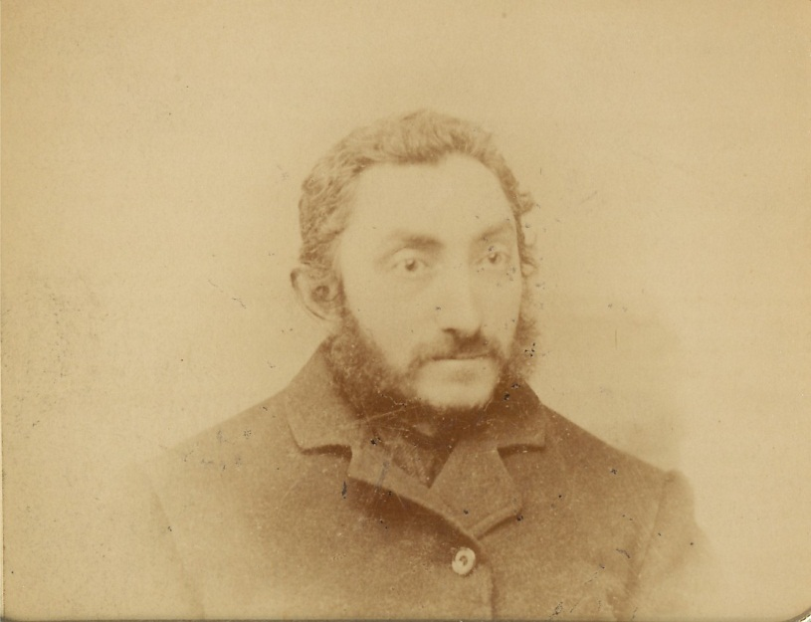

Here’s a copy of the Family Tree that Ann Zinn Buffam got from her mother Roberta (named for Robertina) “Bobby” Moss Zinn. It is complete through 1930 (it does not include Viola Moss Levinson and Meyer Levinson’s daughter Marcia Jane Levinson, born in 1931).



The Mid-1800’s

**THE HEYDERMAN FAMILY**

The second generation we know by name on the Heyderman side are the four children of S. Gruneck and Sarah Nurenberg Gruneck of Germany: Celia, Lena, Herman, and our direct ancestor Augusta (“Golde”) Gruenick. Augusta (“Golde”) was born in Germany in 1835, immigrated to the United States, married Meier (Meyer) Heyderman (perhaps in Germany; perhaps in America).

Meier Heyderman (it is written “Meyer” on the Moss Family Bible family tree) was himself one of four children of Samuel Heyderman and Rose Bernstein (Benestein?). Meyer had three siblings: Bertha, (?), and Sophia.

Meier Heyderman and Augusta (“Golde”) Gruenick Heyderman had six children: Herman, Solomon, Bertha, Aaron, Moses, and Emma Heyderman, the last being our American-born direct ancestor, born August 11, 1864.

The Heydermans were in all likelihood in New York City by the mid-1850’s. Here’s a painting of New York City in 1855, looking south from what is today 42nd Street. In the foreground, the structure on the left is the reservoir (today the site of the New York Public Library). Edgar Allen Poe liked to walk the perimeter. The structure on the right is the old Crystal Palace (today the site of Bryant Park).

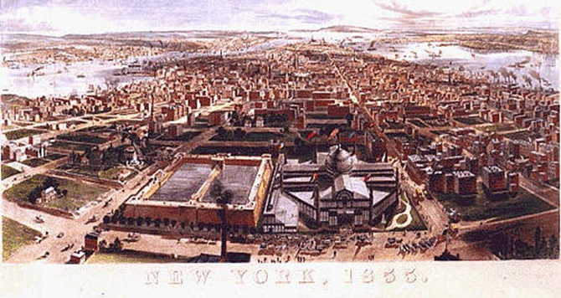

And here’s a picture of Broadway in 1860. Notice the cobblestone streets, horse-drawn carts (and “omnibus” carriages), and [gas-light](http://en.wikipedia.org/wiki/Gas_lighting) (wide-spread by the time).

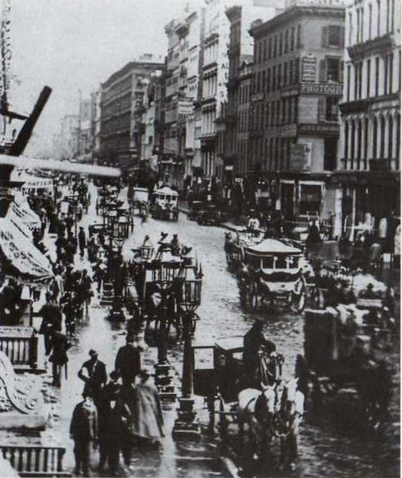

The oldest family story I know of – I heard it from my mother Marcia Levinson Sameth many years ago – is that someone in the family had made uniforms for the Union Army during the Civil War. I learned from my research that that person was Meier Heyderman. On his death certificate, his occupation is listed as “button-hole maker”. During the Civil War almost all buttonholes were sewn by hand (the first automatic buttonhole maker not being invented until 1862). [The National Civil War Association](http://www.ncwa.org/index.php?id=36&option=com_content&task=view) has a page describing the process. More on hand-stitching of buttonholes can be found on the website of [USHist.com](http://www.ushist.com/general-information/hand-stitch_buttonholes.shtml). Meier Heyderman would have used specialized button-hole scissors. Here’s one from 1852:

[](http://images.cloud.worthpoint.com/wpimages/images/images1/1/0311/06/1_8c678df62a648b08a83eae8a93834b46.jpg)

It appeared on-line for sale through [e-bay/WorthPoint.](http://www.worthpoint.com/worthopedia/1852-walcotts-patent-button-hole-136153730) The description called it an early patented pair of buttonhole cutter scissors with a steel cutter and an adjustable brass anvil, Walcott's Patent July 17, 1852. The other side is engraved Walcott Brothers Man’frs. The measuring lines on the brass are still quite clear. The brass adjusting knob works freely. This is the early 6 inch model.

And here’s another version of buttonhole scissors, this from 1864:

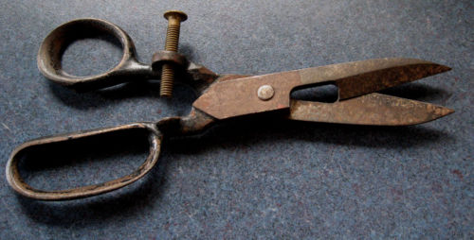

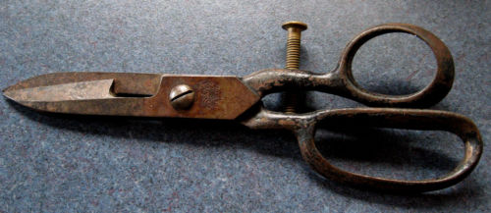

This pair was also found for sale on-line through e-bay. The [description](http://www.ebay.com/itm/Button-Hole-Scissors-Patent-1864-Perfect-Civil-War-Era-Seamstress-/320756028727) was: “Scarce pair of Button Hole Scissors complete with original brass adjustment screw, diminutive size, 5 3/4 inches over all, good condition minor staining. Marked B.S.&Co.PAT. DEC. 1864, the perfect item for cutting the button holes on all those uniforms. The perfect item for the Civil War Seamstress.” According to [Wikipedia,](http://en.wikipedia.org/wiki/Buttonhole) buttonholes for fastening or closing clothing with buttons appeared first in [Germany](http://en.wikipedia.org/wiki/Germany) in the 13th century. Somehow it does not surprise that our Jewish German-American ancestor Meier Heyderman made his living this way - as surprising as it may be to learn that our ancestors have been in the United States long enough to have made a contribution to the Union Army during the Civil War.

In 1862, [Henry Alonzo House](http://en.wikipedia.org/wiki/Henry_Alonzo_House) invented the first buttonhole machine. It was a stunning achievement, and yet not without controversy: it was going to put a lot of workers out of their jobs! (Sound familiar?) As reported on Wikipedia: The machine was tested “in a clothing shop in New York on army overcoats and capes, where its average was from 1,000 to 1,200 buttonholes per day. This caused hard feelings among the hand buttonhole workers, and one day during the noon hour they smashed the machine. However, the next morning another machine was working in its place. All together there were over one hundred thousand button holes made there.” A slightly later version of the automatic button-hole machine can be seen online at [Sewmuse.](http://www.sewmuse.co.uk/americanabho.htm) You can see a variety of Civil War Union uniforms (reproductions) at [ushist.com.](http://www.ushist.com/american_civil-war_uniforms_f.shtml)  And you can view an illustrated history of New York City during the Civil War on [About.com](http://history1800s.about.com/od/civilwar/ig/New-York-City-Draft-Riots/Manhattan-Scene-in-1861.htm). And here’s something on the [manufacture of uniforms](http://opinionator.blogs.nytimes.com/2011/05/09/the-unions-shoddy-aristocracy/) during the Civil War. And [here’s another](http://webcache.googleusercontent.com/search?hl=en&num=10&lr=&ft=i&cr=&safe=images&q=cache:JPbGU0RwEmwJ:http://brooklynhistory.org/blog/author/sgibson/+history+manufacture+union+army+%22civil+war+uniform%22+-reproduction&ct=clnk) article.

Perhaps one of the cousins in the future will take it upon himself/herself to do some research of European records. But at the moment, the earliest historical record we have of either the Heyderman or Moss family is from the U.S. [1870 Federal Census.](http://en.wikipedia.org/wiki/1870_United_States_Census) On July 7, 1870, the census taker, surveying the First District of the Thirteenth Ward of Manhattan, collected the following information about the Heyderman family:

Heyderman, Meyer [note the spelling] 33 tailor born in Prussia not a citizen

_________, Augusta 32 born in Prussia not a citizen

_________, Amelia [presumably Emma] 6 born in New York attends school

_________, Marx [presumably Herman Max] 3 born in New York

_________, Elizabeth [presumably Bertha] 9/12 born in New York

You can view of copy of the actual page this census information appears on, zoom in and get a closer look, at [FamilySearch.org.](https://familysearch.org/pal:/MM9.1.2/M4T2-CDJ/p_279548163)

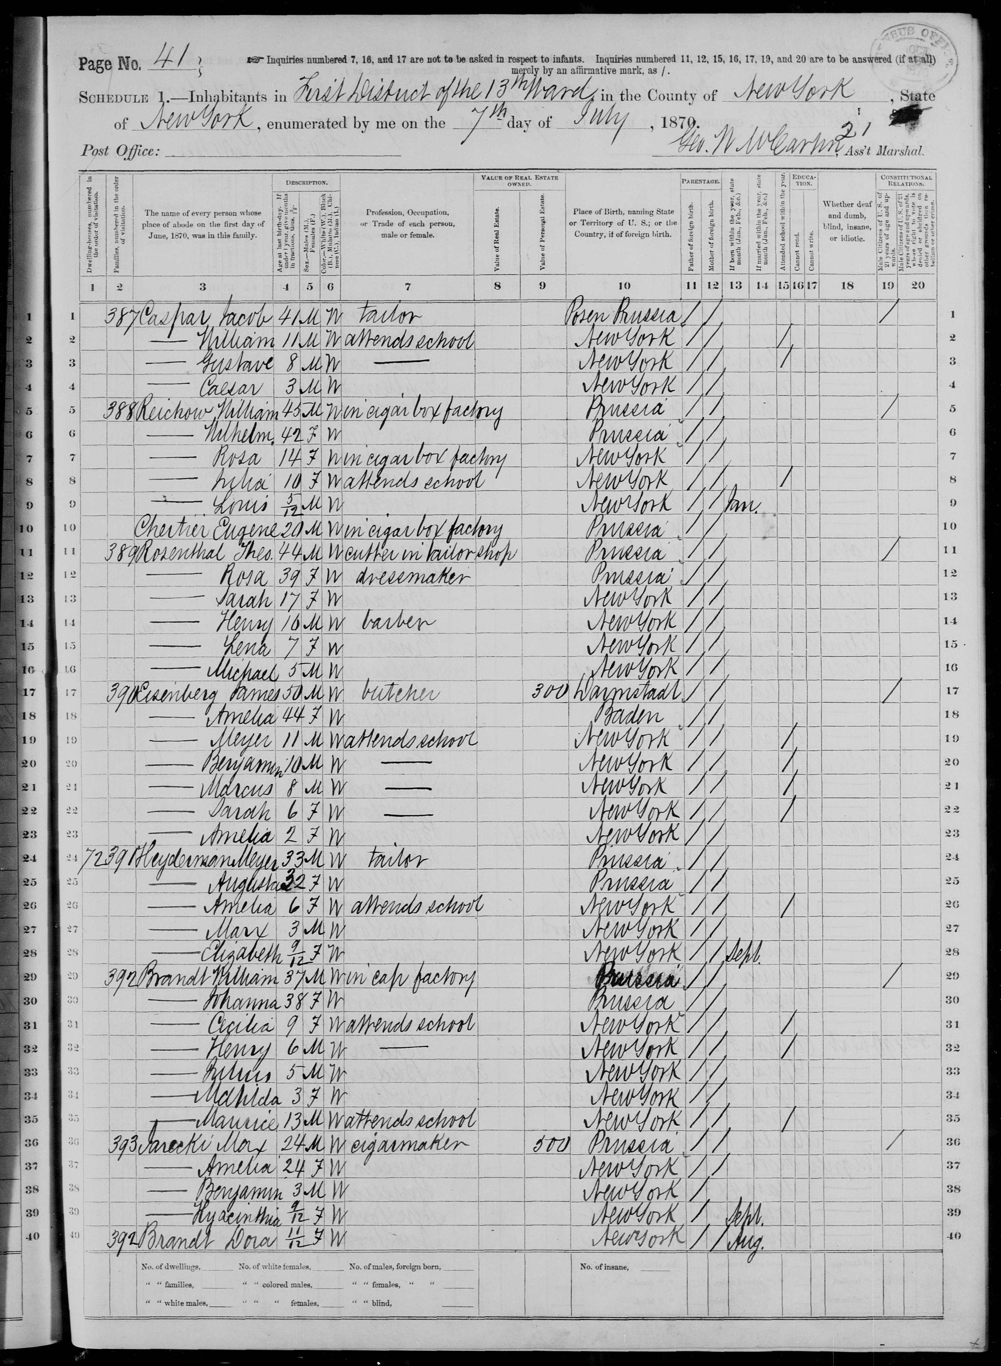

Unfortunately, as you’ll notice, the census taker neglected to write down the name of the street! All we have is the house number: 72. The street that was surveyed just prior to this was “Grand Street between Suffolk and Norfolk” So we know that the Heyderman’s lived nearby on the Lower East Side. It looks like Augusta and Meyer Heyderman had six children: Emma (August 11, 1864), Herman Max (1867), Bertha (1869), and Aaron Isaac (1871) and Solomon (1872). The sixth child, Moses, did not survive, and his birthdate and date of death are unknown at this time.

Here’s a picture of Grand Street taken by the famed photographer Bernice Abbott. It was taken in 1937 but is said to show a portion of the street unchanged since the 1800’s

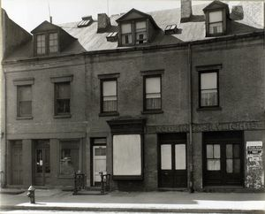

Grand Street in the 1880’s was the great shopping street:

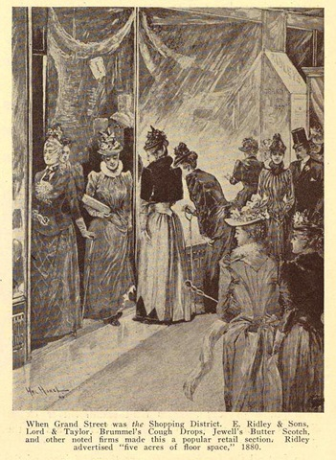

You can view a short video on the Lower East Side (1860’s – 1880’s) on [Youtube.](http://www.youtube.com/watch?v=vzT8EqhuYxA&feature=related)  Look as well at the [New York Public Library Picture Collection](http://digital.nypl.org/mmpco/searchresultsK.cfm?keyword=New+York+City) on-line.

The Heydermans almost assuredly belonged to the German Reform congregation just up the street from them, *Anshe Chesed* Synagogue (also known as the [Norfolk Street Congregation](http://tenement-museum.blogspot.com/2011/08/meet-neighbors-angel-orensanz-center.html) and later as *Anshe Slonim* Synagogue) located at 172-176 Norfolk Street, just south of East Houston Street, between east Houston and [Stanton Street](http://en.wikipedia.org/wiki/Stanton_Street) on the Lower East Side of New York City, NY, a [Gothic Revival](http://en.wikipedia.org/wiki/Gothic_Revival) [synagogue](http://en.wikipedia.org/wiki/Synagogue), built in 1849 for Congregation *Ansche Chesed,* it was the first German Jewish synagogue in New York. In the 1850’s it had the largest membership of any synagogue in the United States. The building still stands, and is currently the home of the [Angel Orensanz Center](http://en.wikipedia.org/wiki/Angel_Orensanz_Center). It is often rented out for private affairs (indeed I officiated at a wedding there in the late 1990’s).

In 1853 another Reform synagogue was built by German Jewish immigrants at 8 Clinton Street (just south of Houston). Congregation Rodeph Shalom had been founded in 1842; one of the oldest Reform congregations in New York City. It eventually moved to the Upper West Side (in 1891 the Clinton Street building was taken over by a congregation of Polish Jews.) The Clinton Street building is still in use today - by Congregation Chasam Sopher - making it the second -oldest synagogue in the city. You can see a picture [here.](http://www.panoramio.com/photo/31727163)

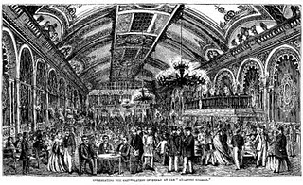

To get a flavor of the world our inhabited by our early German-American ancestors in America, you’d have to step out of the synagogue and enter the palatial German beer hall called “Atlantic Garden” (picture above) which opened on the Bowery in 1858. According to [Robert W. Snyder](http://www.placematters.net/files/flash/bowery/9.swf), historian and professor of journalism and media studies, Rutgers-Newark:

The [Atlantic Garden](http://books.google.com/books?id=lDXAg0nh-OgC&pg=PA49&lpg=PA49&dq=Bowery+%22Atlantic+Garden%22&source=bl&ots=UC7V6I2d04&sig=Q2pBscq9bd2M8_AmzRYHm52hnw0&hl=en&ei=GpnTTuTrO-Ho0QGeio3rBw&sa=X&oi=book_result&ct=result&resnum=8&ved=0CEIQ6AEwBw#v=onepage&q=Bowery%20%22Atlantic%20Garden%22&f=false), a beer hall frequented by German immigrants, confounded middle-class Americans’ beliefs that the mixing of men, women and drink led automatically to vice. A reporter for *Harper’s New Monthly Magazine* who visited the Atlantic in 1871, observed, “On every side are family groups father, mother, and children all merry, all sociable, all well-behaved and quiet. There is not the remotest danger of insult or disturbance, or need of the presence of any policeman. The Germans are proud to keep up the respectability of the place to which they bring their female friends and relatives, and we hope they may fully succeed in maintaining it.”

The Bowery marked the western edge of the German immigrant neighborhood *Kleindeutschland* – Little Germany – and the Germans who inhabited Lower Manhattan in the middle of the nineteenth century practiced a gregarious sociability that contributed to an erosion of the rigid world of Victorianism. Stephen Crane, whose journalism frequently depicted urban scenes, included what is thought to be a thinly veiled description of the Atlantic in his novel *Maggie: Girl of the Streets* first published in 1893. “The great body of the crowd was composed of people who showed that all day they strove with their hands,” he wrote. “Quiet Germans with maybe their wives and two or three children, sat listening to the music, with the expressions of happy cows.”

The Atlantic “sported several bars, a shooting gallery, billiard tables, bowling alleys, and an orchestra. Octogenarian Charles Haswell [interviewed for the 2001 book [*Five Points: The Nineteenth Century Neighborhood That Invented Tap*](http://books.google.com/books?id=NbQa9adIJfkC&pg=PA177&lpg=PA177&dq=Bowery+%22Atlantic+Garden%22&source=bl&ots=4ecO4foY44&sig=txEUSYYkl8aBqOnKQFyoDWo5NQQ&hl=en&ei=GpnTTuTrO-Ho0QGeio3rBw&sa=X&oi=book_result&ct=result&resnum=10&ved=0CEsQ6AEwCQ#v=onepage&q=Bowery%20%22Atlantic%20Garden%22&f=false)*…*] remembered its dense clouds of tobacco-smoke, and hurry of waiters, and banging of glasses, and calling for beer.”

The Atlantic remained a popular German Beer Hall until 1910. By that time the Lower East Side had become the home of Eastern European Jews, and The Atlantic was converted to a Yiddish vaudeville theater.

The Atlantic was far from the only place in the neighborhood to go for beer. In 1864 John Schneider had placed an announcement in the local New York German language paper [*New Yorker Staats Zeitung*](http://tenement-museum.blogspot.com/2009/10/awash-in-beer-history-tapping-into.html) advertising his own new family friendly tavern at 97 Orchard Street. And meanwhile, according to the [Tenement Museum Blogpost](http://tenement-museum.blogspot.com/2009/10/awash-in-beer-history-tapping-into.html)

Just a ferry ride across the East River and a three-cent train ride away, another John Schneider (no relation) was hard at work in Brooklyn's “German Town” - what is today the neighborhoods of Williamsburg and Bushwick. This John Schneider was also in the beer business, perfecting his next lager recipe, training brewers, many of whom would go on to become beer barons in their own right, and operating a beer garden and hall adjacent to his brewery.

With the extension of the railroad line from downtown Brooklyn out to Bushwick and Williamsburg in the late 1850s, many more visitors could enjoy a day in the beer gardens of German Town for less than ten cents. The Brooklyn Daily Times declared about Schneider's hall in 1861 that

“Schneider’s brewery is known far and near as the largest one making the best lager and having the jolliest, best-natured proprietor of any in this city. His gardens and his halle are also the largest, finest, and most aristocratic of any in the State. During the warm weather thousands daily visit them, lounge around, play billiards, listen to the sweetest of music and – drink lager of course.”

Schneider's business was so successful in those days that by 1870 his brewery, beer gardens, and hall had expanded to nearly an entire block, taking up 20 lots in the heart of a neighborhood that had over 300 saloons and more than 10 breweries at the time.

Perhaps the Heyderman family - of the Little Germany on Lower East Side - and the Moss family – which would eventually settle in the Little Germany of Bushwick, Brooklyn - knew each other somehow through these visits.

**THE MOSS FAMILY**

We’ve been focusing on the Heydermans. Where were the Moss’s at this time? They’ve proven harder to track. We know that George was born in the United States on June 15, 1858 to Benjamin Moss and Robertina Lehman Moss. The family seems to have travelled a lot, witness the census records that show their children’s births in Ohio, Michigan, and New York.

Here’s what we know about the Lehman and Moss families: Samuel and Theodora Lehman of Austria had five children: Rosalie, Adolph, Daniel, Isadore, and Robertina Lehman, our direct ancestor. Robertina, according to the Family Bible Family Tree, was born in 1836 (possibly in Breslau – the handwriting on the photocopy I have is hard to make out); she immigrated to the United States, and was married to Benjamin Moss (perhaps in Austria, perhaps in America), and had eight children. They were: Our direct ancestor George, born June 15, 1858; Matthew (born, according to the [1900 census,](http://www.familysearch.org/eng/search/frameset_search.asp?PAGE=/eng/search/ancestorsearchresults.asp) in Ohio in 1860); Henry (born, according to the 1900 census, in Ohio in 1862); Samuel: Benjamin (born, according to the 1900 census, in New York in 1864); David R. (born, according to the 1900 census, in Michigan in 1871); Theodore, and Pauline. Benjamin Franklin Moss was born in 1883 (the year the Brooklyn Bridge opened) on the Lower East Side of Manhattan - so he told his son Nathan. So George and Emma apparently began their family there, before moving to Bushwick, Brooklyn (perhaps in the 1880’s; certainly by the 1890’s).

The New York Public Library has on line an amazing collection of [old pictures of Brooklyn](http://digitalgallery.nypl.org/nypldigital/explore/dgexplore.cfm?topic=all&col_id=219). There’s also the [NYPL Digital Gallery.](http://digitalgallery.nypl.org/nypldigital/explore/dgexplore.cfm?topic=all&col_id=186)

The Late 1800’s

**THE HEYDERMAN FAMILY**

A census was taken 1880. Many of the names (as often happened) were spelled incorrectly. It shows Meier and Augusta with five children, aged 8 to 15. So far, I’ve only been able to look at an [abstract.](https://familysearch.org/pal:/MM9.1.2/M4J7-B4N/p_253539504) Here’s what it says:

Morris [presumably Meier] Heiderman* M 43 Button hole maker

Spouse [Augusta Heiderman](https://familysearch.org/pal:/MM9.1.2/M4J7-B4N/p_253539505) F 43

Child [Emily [presumably Emma] Heiderman](https://familysearch.org/pal:/MM9.1.2/M4J7-B4N/p_253539506) F 15

Child [Marx [presumably Herman Max] Heiderman](https://familysearch.org/pal:/MM9.1.2/M4J7-B4N/p_253539507) M 14

Child [Solomon Heiderman](https://familysearch.org/pal:/MM9.1.2/M4J7-B4N/p_253539508) M 9

Child [Betsey [presumably Bertha] Heiderman](https://familysearch.org/pal:/MM9.1.2/M4J7-B4N/p_253539509) F 11

Child [Aaron Heiderman](https://familysearch.org/pal:/MM9.1.2/M4J7-B4N/p_253539510) M 8

*Note the incorrect spelling of the name

The actual census is NARA Film Number: T9-0873 Page: 131 Page Character: A Entry Number: 4689 Film number: 1254873. Read an article on the [1880 Census](https://www.familysearch.org/learn/wiki/en/United_States_Census_1880). Perhaps this is viewable in person at the New York Public Library; hopefully it would include their 1880 address. Here’s a picture of the Lower East Side (Hester Street) as it looked in the late 1800’s:

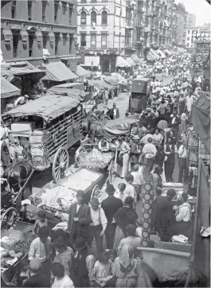

Seven years after this census was taken, on October 16, 1887, Herman M. Heyderman married Pauline Goodman. (Go to [Family Search](http://www.familysearch.org/Eng/Search/frameset_search.asp?PAGE=igi/search_IGI.asp&clear_form=true) and then type in the information to view.) By 1900 Herman and Pauline lived at 428 East 77th Street with their three daughters Sadie (9), Birdie [Bertha?] (8) and Tessie (6). You can view the actual census page by clicking “view image” [on line here.](https://familysearch.org/pal:/MM9.1.2/1BK9-BQL/p_64450930)

Only a year after Herman and Pauline married, the oldest surviving motion picture film was made. Click here and take a look at [the world in 1888.](http://www.youtube.com/watch?v=myQpkIlv_lw&feature=related) And here’s [another film from 1888](http://www.youtube.com/watch?v=59xD2jA4T1E&feature=related) .

On November 28, 1894, in an article in a trade publication about a strike, an “H. M. Hyderman” is identified as the superintendent of the Arnstein Bros. and Co., 45 John Street, NYC. This is without doubt Meier and Augusta Heyderman’s son Herman Max. Arnstein Bros. was a jewelry factory. Years later Marcia Levinson Sameth would tell me that she had heard that Hydermans had been diamond cutters in Germany, a skill they brought over with them from Europe.

According to the article in the trade publication *The Jewelers’ Circular* the diamond trade was in its infancy in the United States. Factories were being struck, and Emma’s brother Herman is quoted in the article as saying that his workers could only have struck in sympathy with the others because Arnstein Bros. was already paying the wage demanded.

Strike of the Diamond Cutters of New York

America’s infant industry, diamond cutting, is now affected by the same trouble that has paralyzed its parent in Amsterdam, a strike. Monday was the time that it commenced to take effect and at the time of The Circular 's going to press the strike had not, it seemed, reached its full proportions.

From what a Circular reporter learned it appears that in some establishments there has been a disagreement between employers and employes over the amount paid per mill to setters. This has been generally $2.50, but a demand for $3.00 and even $3.50 has been made, and, as the setters are paid by the polishers, the demand necessitates that the latter in turn be paid more. The strike commenced at the factory of Wallach & Schiele, 128 Mott St., New York, about 35 of the 40 men employed going out. The men of Arnstein Bros. & Co.'s factory at 45 John St., followed and the strike quickly became general. Men from Wallach & Schiele's went to the factory of Stern Bros. & Co., 29 Gold St., and soon induced about 80 of the polishers and setters there employed to join them. The number was also increased by the 25 hands employed in the factory of Herman Levy, 15 Dutch St., and six of the 15 employees of D. De Sola Mendez & Co., 61 Maiden Lane.

A meeting of the strikers was later held at their headquarters in Bleecker St., where preparations, it is said, were made for the formation of a union, and a scale of prices agreed to. A Circular reporter was told that [representatives from the employes of Zilver Bros.' factory, in Brooklyn and the Sanders & Bruhl works, Newark, N. J., attended this meeting. This however, could not be verified. Mr. Lilienthal, manager of the latter concern, refused to be interviewed about the strike.

When a Circular reporter called at Stern's factory he found the upper floors deserted, but the lower floor which is run for the firm by Soloman and J. H. Hudemacher was working full blast, none of these workmen having, up to that time, joined the strikers. Leopold Stern characterized the strike as the work of foreign socialistic agitators. His men, he said, were getting good wages and steady work and must have been intoxicated by their own prosperity when they thought of joining in the movement. The men were steadily employed for the last 12 months and were thoroughly satisfied. The setters had recently demanded $3.00 per mill instead of $2.75, but an amicable arrangement had been made Saturday last to which all the employes agreed. He had received no further demands and had no intimation of the strike. During a temporary stop of the machinery, the strikers happened to come in and soon induced about 75 of their men to join the movement.

At the Arnstein factory H. M. Heyderman, the superintendent, stated that the employes must have struck through "sympathy" as his firm was paying the setters the amount they demanded from other factories, namely, $3.00 per mill…

The Jewelers’ Circular, November 28, 1894

You can see a copy of the [actual article online here.](http://books.google.com/books?id=y3QoAAAAYAAJ&pg=RA2-PA36&dq=%22Herman+Heyderman%22&hl=en#v=onepage&q=Hyder&f=false) That same year, 1894, Edison took this of [movie of Annie Oakley](http://www.youtube.com/watch?v=zTiDz7PhQSM&feature=related)

The following year, on February 17, 1895 Emma’s brother Solomon Heyderman married Lucy Frank. View the abstract by [clicking here](http://www.familysearch.org/Eng/Search/frameset_search.asp?PAGE=igi/search_IGI.asp&clear_form=true) and typing in the information. Here’s a view of New York City (Herald Square) just a year later, on [May 11, 1896.](http://www.youtube.com/watch?v=zVsVM3mg_dE&feature=related)

January 12, 1898 Emma’s brother Aaron Heyderman shows up in the public record as the best man at a wedding reported on in *The New York Times.*

A DAY’S WEDDINGS

___________

Schnitzler-Friedman

More than 250 guests assembled in Vienna Hall, Fifty-eighth Street and Lexington Avenue, last night, to witness the wedding of Miss Rose Friedman, daughter of Mr. and Mrs. Isaac Friedman of 62 East Sixty-seventh Street, to Abraham Schnitzler. The ceremony was performed by the Rev. Stephen S. Wise Aaron Heyderman was best man. The bridesmaids were Miss Sarah Schnitzler, Miss Hattie Dattelbaum, Miss Jennie Peck, and Miss Lillie Goldberg. The ushers were George Schnitzler, Samuel Schnitzler, Charles Spilka, and Herman Heast. The bride wore a gown of white satin and duchesse lace, with bridal veil of tulle, held by a diamond tiara, the gift of the bridegroom. A reception followed the ceremony. Mr. and Mrs. Schnitzler will spend their honeymoon in the South.

The New York Times, January 12, 1898

You can see a [copy of the actual article](http://query.nytimes.com/mem/archive-free/pdf?res=F00611FC3D5C11738DDDAB0994D9405B8885F0D3) on line. (Note to anyone doing future research: There are no Heydermans buried at Central Synagogue’s Heritage Hills Cemetery in Hastings on Hudson, NY; I’ve been unable so far to locate the family plot.)

Four months later, according to the Manhattan death certificate, on May 21, 1898, Emma’s father Meier Heyderman passed away. The death certificate notes that he was born in Germany, and died at the age of 60 (putting his birth in 1838; and his age at Emma’s birth in 1864 as 26.) Meier’s parents are listed as “Samuel and Ronie [a corruption of Rose] Heyderman” of Germany. His occupation was button-hole maker. According to the handwritten note of his daughter Emma Heyderman Moss in the Family Bible he died on May 22: “My dear Father died Rochcadish Seven 3 days before Shavuos. May 22 1898.” May 21 was a Saturday, Shabbat. “Rochcadish Seven” (ie, “Rosh Chodesh Sivan” or the first of Sivan) began at sundown that night. He likely died that Saturday night (although it would not have been “3 days before Shavuos” - Shavuot, or “The Feast of Weeks” - but more like five days before.)

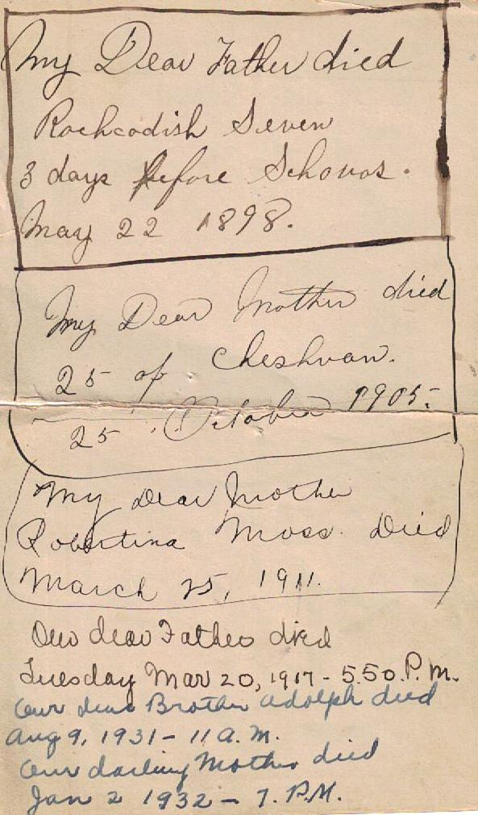

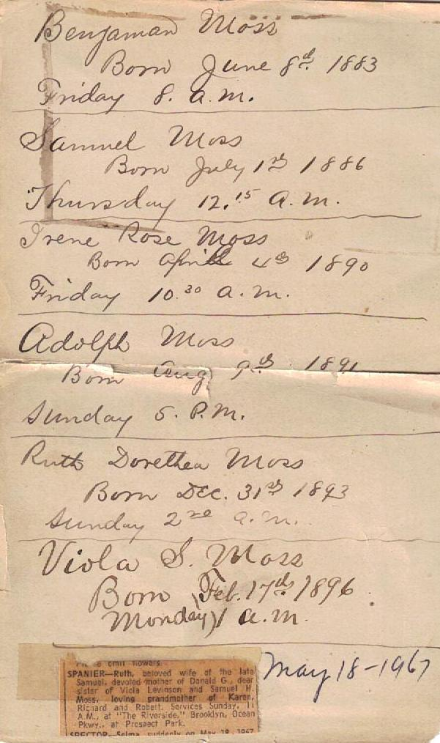

A year and a half later, on September 8, 1899, Meier’s widow remarried. As the marriage certificate had it Golde or Auguste Grining Heyderman was married in Manhattan to Solomon Stone. His parents are listed as Isaac Stone and Sarah Brandt. Her parents are listed as “Father: [Samuel Grinning](http://www.familysearch.org/eng/search/IGI/individual_record.asp?recid=100315033259&lds=1&region=11&frompage=99); Mother: [Zirl Nurenberg](http://www.familysearch.org/eng/search/IGI/individual_record.asp?recid=100315033260&lds=1&region=11&frompage=99).” Solomon was born in Russia Poland; Auguste was born in Germany. The redacted information is online at [Familysearch.org](http://www.familysearch.org/eng/search/frameset_search.asp?PAGE=/eng/search/ancestorsearchresults.asp) (click, and then search for Solomon Stone New York Marriage 1899). They lived in the then-new neighborhood of Morningside Heights, just above Central Park.

**THE MOSS FAMILY**

In 1882, according to the Moss Bible family tree, Emma Heyderman was married to George Moss. A story that came down to us from my grandmother Viola Levinson – via her daughter, my mother Marcia Levinson Sameth – is that Emma Heyderman Moss had walked across the [Brooklyn Bridge](http://en.wikipedia.org/wiki/Brooklyn_Bridge) the day it opened. Quite a story! But it gets better! When I looked at the records, I saw that George and Emma’s first child, Benjamin Franklin Moss, was born in June, 1883. Well the [opening day of the Brooklyn Bridge](http://www.picturehistory.com/product/id/1799) was May 24, 1883. That means that Emma was eight – maybe almost nine - months pregnant when she made her famous walk across the [bridge](http://www.picturehistory.com/product/id/1800). The bridge had been thirteen years in building, and apparently Emma was not going to miss the [festivities](http://mapsites.net/gotham/webpages/gabbyl/opening.htm). (Note to future researchers: It would be interesting to locate Benjamin Franklin Moss’s birth certificate to see where the family was living at the time. Benjamin Franklin Moss’s son Nathan told me that his father had said he had grown up on the Lower East Side of Manhattan. At some point they moved to Bushwick, perhaps bin the 1880’s; certainly by the 1890’s. [Gates Avenue](http://en.wikipedia.org/wiki/Gates_Avenue_%28BMT_Jamaica_Line%29) is the oldest remaining [subway station](http://www.flickr.com/photos/newyorktransitmuseum/5497808492/%20Lexington%20Avenue%20Elevated) in the entire system. It opened on May 13, 1885 and from that point on Bushwick was easily connected to the rest of the city.)

Over the course of thirteen years, between 1883 and 1896, George and Emma would have six children:

Benjamin Franklin Moss, June 1883 (would marry Grace Szerlip; sons George & Nathan)

Samuel H. Moss, July 1886 (would marry Lillian May; daughter Marjorie)

Irene Rose Moss, April 1890 (would marry Edward Strumph; sons George and Robert) Adolph Moss, August 1891 (would marry Paula Marcus; children Ira, Sandy, Roberta)

Ruth Dorothea Moss, December 1894 (would marry Sam Spanier; son Donald)

Viola Sarah Moss, February 1896 (would marry Meyer Levinson; daughter Marcia)

My grandmother Vi – even when she was in her 80’s – spoke about herself as the “baby” of the family. Well, here’s a movie of [New York City in 1896,](http://www.youtube.com/watch?v=zVsVM3mg_dE&feature=player_detailpage) the year Viola was born. And a [famous kiss](http://www.youtube.com/watch?v=zURTEs8C1lo&feature=related) from that same year.

By the 1890’s – if not before – the Moss family was in [Bushwick.](http://en.wikipedia.org/wiki/Bushwick,_Brooklyn) The kids went to [PS 151](http://schools.nyc.gov/SchoolPortals/32/K151/default.htm) 763 Knickerbocker Avenue on Irving Square, just a few blocks from their home on Eldert Street. Here’s a [map of the area](http://www.brooklyn.com/map.php?marker=-73.908695&40.693298&16&M&T=P.S._151_Lyndon_B._Johnson_School%5bbr%5d763_Knickerbocker_Ave%5bbr%5dBrooklyn%5bspc%5dNY%5bspc%5d11207%5bbr%5dApproximate%5bspc%5dNumber%5bspc%5dof%5bspc%5dStudents%5bspc%5d571) right around PS 151 in Bushwick. Here’s a [street view of](http://www.brooklyn.com/streetview.php?40.693298&-73.908695) the school and of the park – [Irving Square Park](http://www.nycgovparks.org/parks/irvingsquarepark/highlights/11902) - right across the street (unfortunately PS 151 is slightly obscured by scaffolding in this picture).

You can read on line about [Bushwick in the 1880’s.](http://wirednewyork.com/forum/showthread.php?t=4478) It was another “Little Germany” and was filled with German Singing Halls (like The Opera House on Arion Place, between Broadway and Bushwick). You can read about 1800’s culture [on line](http://kclibrary.lonestar.edu/19thcentury.html).

It’s no surprise to learn that Bushwick – Little Germany – was famous for its [breweries](http://bushwick-studio.wikispaces.com/Breweries+in+Bushwick). An influx of German-speaking immigrants had brought their centuries-old knowledge of beer brewing to the area between 1840 and 1860. By that time most of the immigrants to Bushwick were German, joining the Dutch who had long lived in this old farming area. The El came in 1885, and the area really grew. As late as the 1960’s and 1970’s – when Bushwick hit very [hard times](http://www.upfromflames.com/) - one could see the old style wood row houses favored by the Germans.

By the late-nineteenth century, Bushwick’s “Brewer’s Row” was producing much of the country’s beer, including [Diogenes](http://www.flickr.com/photos/eatingintranslation/5396818488/) and once popular though now all-but-forgotten brands like Piel’s and Trommer’s. Eventually Milwaukee became center of the beer industry, and the last of Bushwick’s breweries—[Rheingold](http://www.youtube.com/watch?v=lMpc-u0RoHY) and Schaefer (still wildly popular through the [1950’s)](http://www.youtube.com/watch?v=Rfc4InJ7shk) closed in the 1970’s. In 2010 the offices of the old [Ulmer Brewery](http://en.wikipedia.org/wiki/File:Ulmer_Brewery_Bushwick_Av_Belvedere_St_jeh.jpg) became a [landmark.](http://cityroom.blogs.nytimes.com/2010/05/11/city-raises-glass-to-a-brewery-in-brooklyn/)

Bushwick had many well-known [theatres](http://bushwickbk.com/2010/12/14/a-tour-of-bushwicks-movie-meccas/). The [Bushwick Trolley](http://bushwickbk.com/2009/10/13/central-bushwick-walking-tour-this-saturday/) was running, and it was a short ride on the El to popular Coney Island. The story of Bushwick is alone worth exploring. Lately it’s been written about in the [New York Times](http://www.nytimes.com/2006/03/05/magazine/305bushwick.1.html?pagewanted=all), called “[the coolest place on the planet](http://gawker.com/5590284/is-bushwick-brooklyn-the-coolest-place-on-the-planet)” and spawned its [own local paper.](http://bushwickbk.com) You can take an [on-line tour](http://www.youtube.com/watch?v=2u_D09Dz4uo) of Bushwick today, and see an on-line tribute to the whole [East New York](http://www.youtube.com/watch?v=baC51qnILwE&feature=related) area.

But let’s return to the story of the Moss family of Bushwick, in the late 1800’s. Here’s a photograph of Emma Heyderman Moss taken in Bushwick the 1880’s or 1890’s:

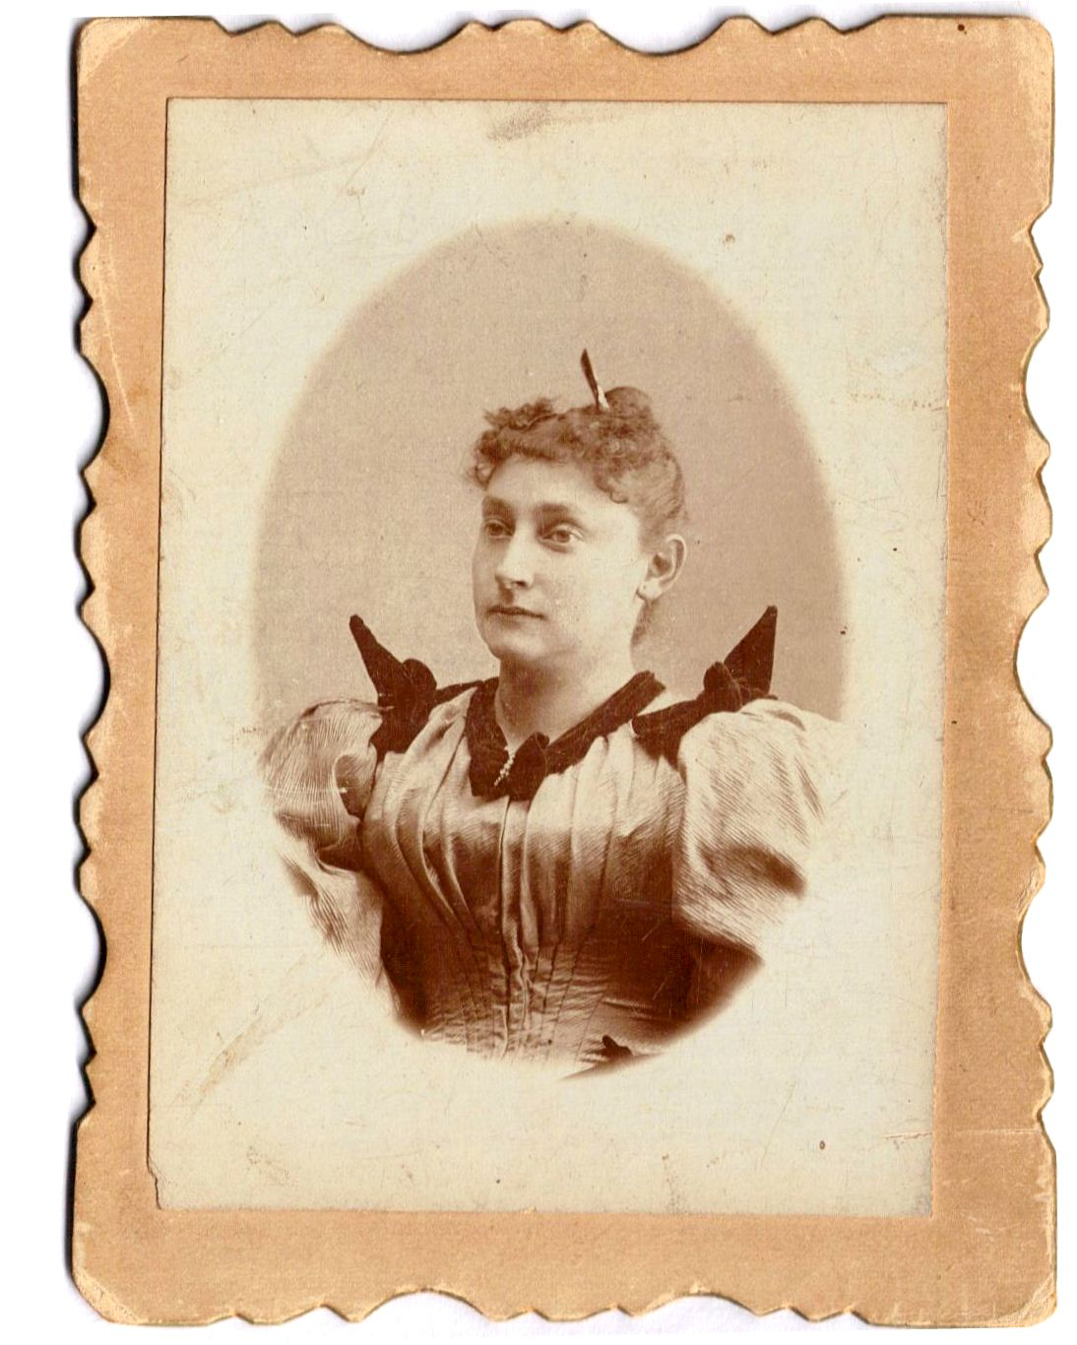

This portrait of Emma Heyderman Moss was taken in the 1880’s or 1890’s. Printed on the back of the picture card is: JEANNETTE PHOTOGRAPHIC STUDIO, 1077 Broadway, Opp. Reid Ave., BROOKLYN, NY. Handwritten in pencil it says: “Mrs. Morse [sic], 132 Eldert St. (From Marcia Levinson Sameth)

Note the hair clip. It looks to be the same as or similar to a hair clip of Emma’s which is today in the possession of her granddaughter Marcia Levinson Sameth. You can read up on the history of Brooklyn on line. The on-line catalog of the [Brooklyn Historical Society](http://brooklynhistory.org/library/wp/new-york-city-and-brooklyn-directories/) is coincidentally named “Emma.” And now here is another portrait - taken at the same studio – of Emma and George’s daughter Viola, who appears to be about three years old. That would make this 1899.

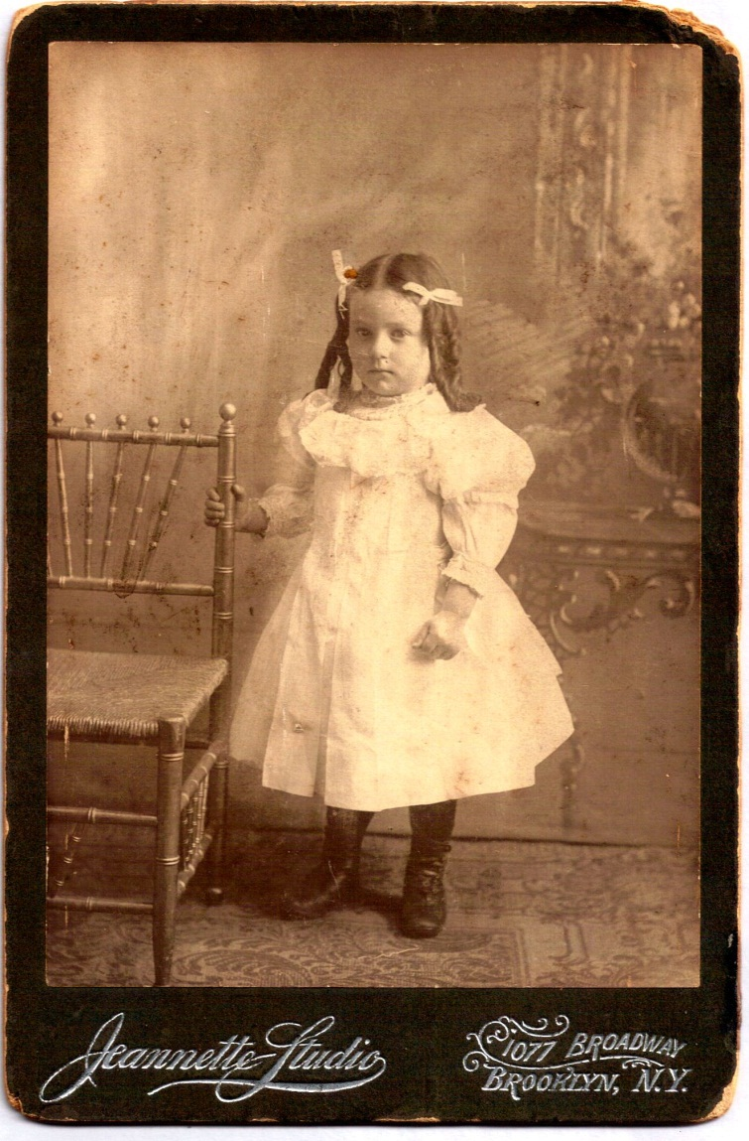

Turn of the Century

The Moss and Heyderman families witnessed the beginning of a new age at the turn of the century. Take a look at [23rd Street](http://www.youtube.com/watch?v=9ZsPk6Qq4TY) in New York City in 1901, or [Lower Broadway](http://www.youtube.com/watch?v=IsrdkySRSCY&feature=related) in 1903, and you’ll still see horse-drawn carts and carriages. But New York in the [early twentieth century](http://www.youtube.com/watch?v=PqLl6cyG_ck&feature=related) was a world on the cusp of very great change. Look at the pictures of [Olde New York](http://www.youtube.com/watch?v=9Im133UxSII&feature=related) and especially of the [Lower East Side](http://www.youtube.com/watch?v=Gt11pMfVcLY&feature=related) and you see the old world giving way to the new.

One of the biggest changes coming was the automobile. Although several other German engineers were working on it at the same time, [Karl Benz](http://en.wikipedia.org/wiki/Karl_Benz) is generally acknowledged as the inventor of the modern automobile. .In 1879, Benz was granted a patent for his first engine, which had been designed in 1878. In 1893, the first running, gasoline-powered [American car](http://en.wikipedia.org/wiki/American_car) was built and road-tested by the [Duryea brothers](http://en.wikipedia.org/wiki/Duryea_brothers) of [Springfield, Massachusetts](http://en.wikipedia.org/wiki/Springfield,_Massachusetts). But the large-scale, [production-line](http://en.wikipedia.org/wiki/Production-line) manufacturing of affordable automobiles was not debuted until 1902 by [Ransom Olds](http://en.wikipedia.org/wiki/Ransom_Olds) at his [Oldsmobile](http://en.wikipedia.org/wiki/Oldsmobile) factory. This concept was greatly expanded upon – and made famous - by [Henry Ford](http://en.wikipedia.org/wiki/Henry_Ford), beginning in 1914. That year an assembly line worker could buy a [Model T](http://en.wikipedia.org/wiki/Automobile) with four months' pay.

Before reading on about our family, you might want to read up on 1900’s [culture](http://kclibrary.lonestar.edu/decade00.html) and [songs](http://rosemck1.tripod.com/jukebox-nostalgia.html). A big song of 1900 was [Meet Me in St. Louis.](http://www.youtube.com/watch?v=DYoGsVaT8vk)

**THE HEYDERMAN FAMILY**

According to the [1900 New York City Census](https://familysearch.org/pal:/MM9.1.1/MSKP-1G4), Augusta “Golde” Heyderman was now re-married to a man named [Solomon Stone](https://familysearch.org/pal:/MM9.1.1/MSKP-1GW) and is living at 116 West 113th Street, NYC, three blocks north of Central Park, just above the park’s [Harlem Meer](http://daytoninmanhattan.blogspot.com/2010/12/central-parks-harlem-meer-boathouse.html), where the family no doubt would have often walked. “Central Park designers Olmsted and Vaux named this man-made water body *the Meer* - Dutch for ‘lake.’ It was a nod to the 17th Century European settlers who first inhabited the village of Harlem.” The whole area, though at the time recently built, had a very European feel to it. Even today you will recognize Lenox Avenue (renamed Malcolm X Boulevard) and 7th Avenue (renamed Adam Clayton Powell Boulevard) as wide, European-style grand boulevards. There’s an on-line map of [Central Park](http://www.centralparknyc.org/maps/) and environs, where you can explore for yourself. Also worth looking at is the collection of pictures of Manhattan streets under construction – including 6th Avenue, later Lenox Avenue ~1871 – available on line at [The Museum of the City of New York](http://collections.mcny.org).

The 1900 census lists Solomon Stone, 76, born May 1824, Russia, as the head of house. Augusta (“Golde”), his wife, 62 years old, was born August, 1837, in Germany, and had five children, all of whom were at the time living. Living with Solomon and Golde are Solomon’s step-son (Golde’s son) Aaron Heyderman, 28 years old, born 1861 (sic); Golde’s daughter Bertha Warshauer (although the census-taker may have written in the word “step” over the word “daughter”), 30, born September 1869, widow of Max Warshauer; Bertha and Max’s daughter Dora (Dorothy) born 8/2/1891 (see Brooklyn birth cert. #29646); and Minnie Weir, 20, seemingly a servant from Sweden. We’ll meet Bertha and Dora again a little further into the story, as the “leapers” at the Martha Washington Hotel.

In 1900 Golde’s son [Herman](https://familysearch.org/pal:/MM9.3.1/TH-266-12342-140209-57?cc=1325221) is living with his wife Pauline on East 77th Street. Herman and Pauline – both of whom apparently were born in February of 1867 – have three daughters: Sadie (9), “Birde” (8), and Tessie (6).

On November 2, 1901 Solomon Stone dies (see Manhattan death certificate [#32895](http://www.italiangen.org/NYCDeathresults.asp?kind=exact&Esurname=Stone&Efirst=Solomon&StartYear=1900&EndYear=1920&County=Manhattan&B1=Submit)).

In 1902 – four years after serving as best man at his [friend’s wedding](http://query.nytimes.com/mem/archive-free/pdf?res=F00611FC3D5C11738DDDAB0994D9405B8885F0D3) – [Aaron Heyderman](https://familysearch.org/pal:/MM9.3.1/TH-267-12390-224320-60?cc=1325221) was himself [married](1902:%20Aaron%20marries%20Rose%20Levin%20(1902)%20http:/www.familysearch.org/Eng/Search/frameset_search.asp?PAGE=igi/search_IGI.asp&clear_form=true), to Rose Levin. The [1905 Census](https://familysearch.org/pal:/MM9.3.1/TH-1-159385-46610-96?cc=1463113) lists [Solomon Hyderman](https://familysearch.org/pal:/MM9.1.2/SMJ5-2WZ/p_2030116499) (33) as a “diamond polisher” and he and his wife Lucy (29) are living at 3 West 112th Street, just a few blocks away from where his mother Emma and step-father Solomon, and older brother Aaron and sister Bertha had been living. That same year Herman and Pauline Heyderman are shown in the [census](https://familysearch.org/pal:/MM9.3.1/TH-267-11865-157773-26?cc=1463113) with three children.

In 1908 [Aaron I. Heyderman](http://books.google.com/books?id=tMUpAAAAYAAJ&pg=PA363&dq=%22Herman+Heyderman%22&hl=en#v=onepage&q=Heyderman&f=false) is the president of Thompson Co, NY, at 840 Broadway. The treasurer is Leo Frank. The same year [Herman M. Heyderman](http://books.google.com/books?id=tMUpAAAAYAAJ&pg=PA363&dq=%22Herman+Heyderman%22&hl=en#v=onepage&q=Heyderman&f=false) is listed as being with Hermalgus Realty (named for Herman and his partners Alphonse Ehrlich, and Gustav Goodman). We find [Herman](http://books.google.com/books?id=ev0BAAAAYAAJ&pg=PA292&dq=%22Herman+Heyderman%22&hl=en#v=onepage&q&f=false) again in 1914. And in 1919 [Aaron](http://books.google.com/books?id=8lQLAAAAYAAJ&pg=PA962&dq=%22Aaron+I+Heyderman%22&hl=en#v=onepage&q=%22Aaron%20I%20Heyderman%22&f=false) turns up as a respondent in a law case.

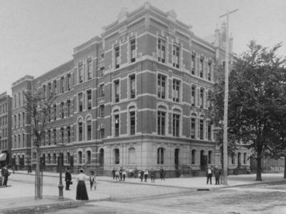

*Lenox Avenue in the Morningside Heights area around the turn of the century (stock photo).*

**THE MOSS FAMILY**

Here’s the [Moss family](https://familysearch.org/pal:/MM9.1.2/1BVX-T5Y/p_62162465) in 1900. The family is living at 132 Eldert Street (Ward 28), Bushwick, Brooklyn. George is a salesman, renting house, born in 1858 in New York. His father was born in Russia, his mother in Germany (and so it seems likely that they met and married in the US). Emma was born August 1864 in New York, and her mother and father were both born in Germany. You can see the actual images of the census by clicking [here](https://familysearch.org/pal:/MM9.3.1/TH-266-12869-174382-10?cc=1325221) (look at the bottom of the page) and [here](https://familysearch.org/pal:/MM9.3.1/TH-266-12869-174820-1?cc=1325221&wc=11724156) (look at the top of the page).

And right down the street – at 69 Eldert Street – is George’s widowed mother [Robertina Moss.](https://familysearch.org/pal:/MM9.1.1/MSNL-1KK) According to the census, she was born in 1838 in Germany and is living in the same building as two other families (the Cozines and the Triebels) with four of her eight unmarried children. Look at their ages!

Matthew b. Sept. 1860 Ohio (39) single Commercial Gan(?) Books

Henry b. 1862 Ohio (37) single Commercial Gan(?) Books

Benjamin b. Sept. 1864 NY (35) single Stencil Cutter

David R. b. April 1871 MICH (29) single Compositer

Three other children (George, who lives down the street; Theodore; and Pauline) live elsewhere; and one (Moses; who does not even appear on the Family Bible Family Tree) is deceased. You can view the actual census page by [clicking here.](https://familysearch.org/pal:/MM9.3.1/TH-266-12869-175179-15?cc=1325221) Note that Robertina’s son Henry – who is single, 37, and living with his mother and three unmarried brothers – will shortly take over his brother’s “Theodore Moss & Co,” and rename it “Henry Moss & Co.”

Robertina Moss’s son [Theodore](https://www.familysearch.org/help/viewdocument?documentId=105534&sliceId=SAL_Public&userQuery=1900+census) – mentioned just above – is living at 125 Cooper Street. Theodore (born March, 1874) and his wife Stella (born 1880) were recently married (about 1899). They have an infant son Lester, born April 1900. Theodore is a stencil cutter. The son Lester seems not to have survived. (My mother Marcia Levinson Sameth remembers visiting Uncle Theodore and Aunt Stella in the 1930’s when she was a little girl, but recalls them as being without children. Marcia remembers that Stella had a “present” closet, and she would always retrieve something special to give Marcia before she left.)

And now here’s a picture of George and Emma Moss’s three daughters (from left to right): Viola, Ruth, and Irene Moss, perhaps around 1900 (in Irving Square Park?). Note the baby doll in the stroller.

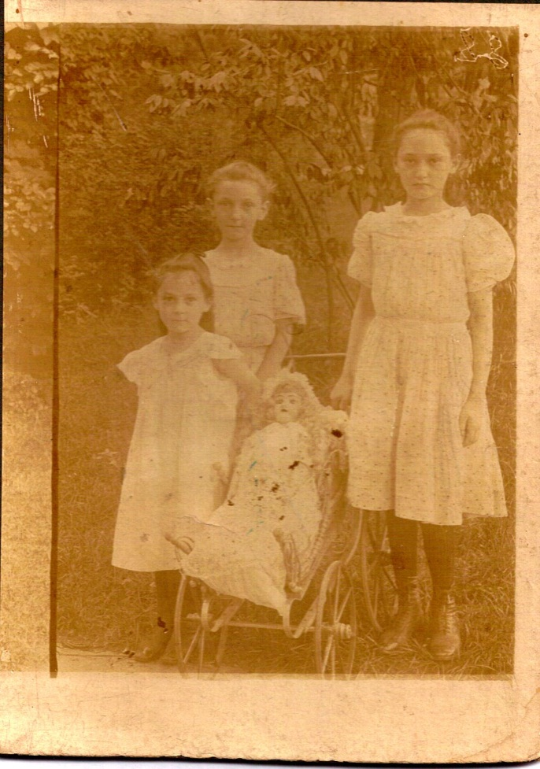

*From Marcia Levinson Sameth.*

In 1905 [Robertina Moss](https://familysearch.org/pal:/MM9.1.2/SMNN-LS3/p_464110486) was 65 years old and was living at 595 Central Avenue (this is between Schaffer and Covert/Joy) in Bushwick with two of her sons. Central Avenue is a street which runs parallel to the larger Bushwick Avenue. You can see the actual census page by [clicking here.](https://familysearch.org/pal:/MM9.3.1/TH-267-11605-71755-26?cc=1463113)  She is living with Matthew, 44 (salesman, books) and Benjamin, 40 (rubber stamps, maker). Also at the same address is Robertina’s daughter Pauline Moss Rosedale (38), and Pauline’s husband Michael Rosedale (40). Michael is listed as “rubber stamp maker.” (Was this the origin of what would later be Samuel H. Moss Rubber Stamps?) Michael and Pauline have four daughters: Adeline, Florence, Clair, and Hazel; and a son Theodore.

Robertina’s son George Moss, his wife Emma Heyderman Moss, and their family have by this time moved up the hill to 522 Bainbridge Street, still in the Bushwick section. George is 42 and is still listed as “salesman.” Emma is 40. Their children are listed by name and occupation: Benjamin 22 (salesman), Samuel H 19 (salesman), Irene 15 (at school), Adolph 12 (at school), Ruth 11 (at school), Viola 9 (at school). By this time they would no longer have attended PS 151 on Irving Square, as they were now living up the hill, on the more fashionable side of Broadway, with its shops under the El, a dividing line of sorts in Bushwick.

Meanwhile, another of Robertina’s sons - Henry - was about to take over the family business which had operated until that time under the name of his brother Theodore. Here’s the announcement dated January 11, 1905. From *The Wine and Spirit Bulletin: Dedicated to the Interests of the Wine & Spirit Trade*, Volume 19, No 1, January 12, 1905 (Louisville, KY and Cincinnati, OH) page 23

Henry Moss & Co

32 Beaver Street

New York, January 11, 1905

We beg to inform our friends and the trade in general that the business heretofore conducted at 32 Beaver Street under the name Theodore Moss & Co., has been dissolved and that the said business will hereafter be conducted under the name Henry Moss & Co., and that all liabilities of the former firm will be assumed and liquidated by the new firm of Henry Moss & Co.; likewise all obligations owing to said former firm should be paid to and settled with the new firm as now constituted.

It will be our endeavor to continue the business policy of the old firm of prompt and efficient service and to do all that should be needful to meet the wishes of all our patrons.

HENRY MOSS & CO.

George Moss was famous for liking liquor (he had said that when he died he wanted people to come and pour a bottle of scotch over his grave) but I hadn’t known that the family had traded in spirits. Henry Moss & Co. would soon either turn from or branch out to other endeavors: metal fabrication and the manufacture of rubber stamps. (Here’s a [link](http://books.google.com/books?id=NRdQAAAAYAAJ&pg=RA1-PA23&lpg=RA1-PA23&dq=%22Henry+Moss+%26+Co%22&source=bl&ots=RuZSzl18ff&sig=eHEcLRqG8ll8y4KvDpaTHGp6GG0&hl=en&ei=PI6xTqLXOsnd0QHwx8HVAQ&sa=X&oi=book_result&ct=result&resnum=3&ved=0CCcQ6AEwAg#v=onepage&q=%22Henry%20Moss%20%26%20Co%22&f=false) where you can see the original of the announcement above on-line.)

Ten months later, Auguste “Golde” Heyderman (Stone) died. It seems that she had moved from Morningside Heights to the home of her daughter Emma and son-in-law George Moss in Bushwick. Emma Moss wrote in the Moss Family Bible “My dear Mother died 25 of Cheshvan. 25 October 1905.”

Indeed, the Brooklyn death certificate (#19909) confirms the date of death for Augusta Heyderman dated October 25, 1905. She was 70 years old at death, meaning she was born in 1835. That would have made her (if correct) three years older than Meier. My grandmother Viola would have been 9 years old when her grandmother “Golde” (Augusta) died; old enough for sure to remember her. And indeed Viola told of seeing her European-born grandmother walking around the house in a long nineteenth century European style black dress, with a black hat or bonnet on her head, using the brass mortar and pestle set that Marcia Sameth has today. It seems likely that that memory of Golde was from the period when Golde was living at their home in Bushwick - at 598 Chauncey Street, just a few steps in from Broadway. (Today it’s part of a large mercantile building that sits at the corner of Broadway. I have a picture of a foreclosed house that sits just down the hill from that building. Note: In the same year, 1905 - either before or after Golde’s death - the family can be found at 522 Bainbridge.)

The information on the death certificate seems incorrect. It says that she died on October 25 (a Wednesday) and was buried on October 28. October 28 was a Saturday, a day when Jewish cemeteries are closed and burials are disallowed. But as I understand it, these records are notoriously inaccurate and will often indicate the name of one cemetery and date of burial when in fact the internment would take place elsewhere. I have not been able to locate where Golde is buried.

No pictures are known to have survived of Golde. Perhaps she dressed something like these women of the time:

[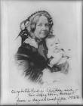](http://www.google.com/imgres?imgurl=http://www.virginiamemory.com/docs/Stanton.jpg&imgrefurl=http://www.virginiamemory.com/online_classroom/shaping_the_constitution/people&usg=__zF6MsUFbLuhc6j6NRxdigGD52I0=&h=700&w=552&sz=42&hl=en&start=795&zoom=1&tbnid=NB4hOHKDwFam8M:&tbnh=140&tbnw=110&ei=tDCfTvy7Larj0QHZo5GkCQ&prev=/search?q=nineteenth+century+german+women&start=777&hl=en&sa=N&gbv=2&tbm=isch&itbs=1) [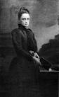](http://www.google.com/imgres?imgurl=http://williamhpeck.org/yahoo_site_admin/assets/images/Bensondarklady.302111920_std.jpg&imgrefurl=http://williamhpeck.org/margaret_benson&usg=__Ttlr9jQc3_4X9_mPjKEsviNYSQE=&h=650&w=400&sz=25&hl=en&start=497&zoom=1&tbnid=L2oDmKeGx1tNLM:&tbnh=137&tbnw=84&ei=GjCfTpa_CKnx0gHFh-muCQ&prev=/search?q=nineteenth+century+german+women&start=483&hl=en&sa=N&gbv=2&tbm=isch&itbs=1) [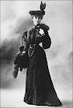](http://www.google.com/imgres?imgurl=http://angelasancartier.net/wp-content/uploads/Paquin-day-dress-1903.jpg&imgrefurl=http://angelasancartier.net/paris-fashion&usg=__GGlrsx4Q6fsvcrVQFFAiGBRP640=&h=696&w=473&sz=58&hl=en&start=594&zoom=1&tbnid=tiXYBm5h21TaFM:&tbnh=139&tbnw=94&ei=TTCfTqaTKYr00gH_8Y2uCQ&prev=/search?q=nineteenth+century+german+women&start=588&hl=en&sa=N&gbv=2&tbm=isch&itbs=1) [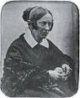](http://www.google.com/imgres?imgurl=http://s3.hubimg.com/u/3773534_f248.jpg&imgrefurl=http://klarawieck.hubpages.com/hub/Women-Composers-and-Musicians-The-Real-Housewives-of-19th-Century-Germany&usg=__6XJeAgNCeNdhIJts9y5YsRxlgks=&h=306&w=248&sz=26&hl=en&start=647&zoom=1&tbnid=rNoqUTyMCUiyTM:&tbnh=117&tbnw=95&ei=czCfTqn1GOTf0QHv3qHDCQ&prev=/search?q=nineteenth+century+german+women&start=630&hl=en&sa=N&gbv=2&tbm=isch&itbs=1) [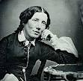](http://www.google.com/imgres?imgurl=http://www.discerninghearts.com/blog/wp-content/uploads/2011/03/Harriet-Beecher-Stowe.jpg&imgrefurl=http://www.discerninghearts.com/?p=2798&usg=__jMoSNJCg0ggHBIsXcbD_flapfXw=&h=243&w=248&sz=20&hl=en&start=747&zoom=1&tbnid=4Dsh8bi-kuvqnM:&tbnh=109&tbnw=111&ei=nTCfTuoFhevSAfPQxacJ&prev=/search?q=nineteenth+century+german+women&start=735&hl=en&sa=N&gbv=2&tbm=isch&itbs=1) [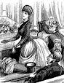](http://www.google.com/imgres?imgurl=http://upload.wikimedia.org/wikipedia/commons/thumb/e/ed/Women_suffrage_cartoon.png/220px-Women_suffrage_cartoon.png&imgrefurl=http://en.wikipedia.org/wiki/Women's_suffrage&usg=__AUm2ov5nIDLpX6yelBwZVWTn1W0=&h=284&w=220&sz=59&hl=en&start=910&zoom=1&tbnid=6NaUGTtt3QWbpM:&tbnh=114&tbnw=88&ei=4jCfTpo8qvLSAamd6ZIJ&prev=/search?q=nineteenth+century+german+women&start=903&hl=en&sa=N&gbv=2&tbm=isch&itbs=1)

[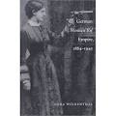](http://www.google.com/imgres?imgurl=http://ak.buy.com/PI/0/350/30763661.jpg&imgrefurl=http://www.buy.com/prod/german-women-for-empire-1884-1945/30763661.html&usg=__gujyVG4k6m2REfX19yIkWfaFEQw=&h=350&w=350&sz=19&hl=en&start=941&zoom=1&tbnid=0_pZKmcmA5TvYM:&tbnh=120&tbnw=120&ei=ADGfTsWJJ8jX0QGspP3HCQ&prev=/search?q=nineteenth+century+german+women&start=924&hl=en&sa=N&gbv=2&tbm=isch&itbs=1) [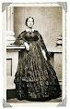](http://www.google.com/imgres?imgurl=http://ohioblogging.com/wp-content/uploads/2008/09/111.gif&imgrefurl=http://ohioblogging.com/2008/09/05/simply-quaker-women-in-plain-dress/&usg=__Lbvxtp9jm685n3S1s1OIqK0g-AE=&h=311&w=203&sz=40&hl=en&start=269&zoom=1&tbnid=iJAvxuTLWcEbXM:&tbnh=117&tbnw=76&ei=czGfTs-GPKjW0QGR-4GQCQ&prev=/search?q=nineteenth+century+women's+clothing&start=252&hl=en&sa=N&gbv=2&tbm=isch&itbs=1) [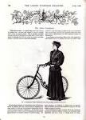](http://www.google.com/imgres?imgurl=http://3.bp.blogspot.com/-rdpzdhNbwW4/Tcfrh7X0K_I/AAAAAAAAAMk/iO4sg9Qy0xo/s1600/bicycle0001.JPG&imgrefurl=http://houseofcaitlinrose.blogspot.com/2011/05/women-and-their-bicycles.html&usg=__D5K5eC9CWn6SuRAXtDqYkRrhfOk=&h=1600&w=1155&sz=346&hl=en&start=378&zoom=1&tbnid=3uOFUAFYtK7vRM:&tbnh=150&tbnw=108&ei=pjGfTruvDaHi0QGK9PSHCQ&prev=/search?q=nineteenth+century+women's+clothing&start=357&hl=en&sa=N&gbv=2&tbm=isch&itbs=1)[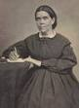](http://www.google.com/imgres?imgurl=http://www.lakeunion.org/site_data/684/assets/0008/3824/3_medium.jpg&imgrefurl=http://lkuc.lakeunion.org/church-history&usg=__j4a-_5pVE1vqUlw0OpslDvk-3oI=&h=250&w=183&sz=24&hl=en&start=824&zoom=1&tbnid=I6zJxwuVPfndBM:&tbnh=111&tbnw=81&ei=UzKfTqb4D6P20gGo0LSXCQ&prev=/search?q=nineteenth+century+women's+clothing&start=819&hl=en&sa=N&gbv=2&tbm=isch&itbs=1) [](http://www.google.com/imgres?imgurl=http://3.bp.blogspot.com/_XUOhqO3dOXI/S5UZjZ4-g6I/AAAAAAAAImo/L0KzT9oqjX8/s400/fredrika.jpg&imgrefurl=http://itsalwaysteatime.blogspot.com/2010_03_01_archive.html&usg=__HjMN1JX05n1qshFuJ3KMyCPjFII=&h=400&w=350&sz=32&hl=en&start=429&zoom=1&tbnid=wvN79jixwDlAjM:&tbnh=124&tbnw=109&ei=7y-fTrmtJaTr0gHeufyrAg&prev=/search?q=nineteenth+century+german+women&start=420&hl=en&sa=N&gbv=2&tbm=isch&itbs=1)

1905 was also the year Buswick’s [DeKalb Library](http://www.brooklynpubliclibrary.org/branch_library_detail.jsp?branchpageid=285) opened at 790 Bushwick Avenue (at the corner of DeKalb Avenue. According to the [Landmark Preservation Commission](http://bushwick-studio.wikispaces.com/Brooklyn+Public+Library,+DeKalb+Branch)

“This landmarked Classical Revival brick and limestone library, designed by William B. Tubby, was completed in 1905 as one of the first library branches in the Borough of Brooklyn funded by a grant by Andrew Carnegie in response to the large population growth in Bushwick during the late 19th and early 20th century, which necessitated a growth of civil services. The double-height windows and rounded apse were designed to let light and air into the library and has served the community for over a century.”

Here’s another [picture](http://www.topix.com/album/detail/brooklyn-ny/P7FQM0V77ONFTUEL) of it.

In 1907 Adolph Moss may have been working as an office boy. An Adolph Moss of 462 Bainbridge Street, Brooklyn is listed in New York State’s “Proceedings of the Public Service Commission for the First ..., Volume 1” (The book is available on Google Books; see page 177.)

In 1910 [Robertina Moss](https://familysearch.org/pal:/MM9.1.2/9K15-S5M/p_582342669)  (72) is living with her daughter Pauline Moss Rosendale (43), Pauline’s husband Michael (43), their five children, and Robertina’s son Benjamin Moss (45). Bushwick was booming in those days, filled now not only with beer halls and breweries but with great [movie houses.](http://bushwickbk.com/2010/12/14/a-tour-of-bushwicks-movie-meccas/) Famous amongst them were the [Amphion](http://playbill.brooklynpubliclibrary.org/enlarge.asp?card=PP-0026) Theatre and the [Bushwick](http://www.flickr.com/photos/theatretalks/5405081697/in/photostream) Theatre. In 1910 my grandmother Viola Moss - 14 years old - is graduated from the 8th grade. It’s her last year of school.

According to the Moss Family Bible family tree 1911 is the year that Robertina died. A handwritten note from George notes her passing.

The Teens

**THE MOSS FAMILY**

Bushwick was predominantly German, but there was a small Italian enclave as well. It has been theorized that the quintessentially American tradition of eating pizza and drinking beer derives from the meeting of these two cultures. Indeed, in 1919 the New York City Police took an interest in mapping the [demographics of the city](http://cityroom.blogs.nytimes.com/2012/01/03/police-demographics-unit-casts-shadows-from-past/?ref=todayspaper).

The 1913 City Directory shows George Moss (salesman) living at 368 Decatur (which is right around the corner from Bainbridge). They moved around a lot in these days. Marcia Levinson Sameth says – only half in jest - that they were probably running from the landlord. It was common to stay a year in one place and then move on- as a landlord would give you a free month’s rent when you moved in.

Decatur, where they now lived, was three blocks over from Eldert and further away from the school; closer to the cemetery. Decatur runs on both sides of Broadway, but Bainbridge only on the far side of Broadway.

For the Mosses of Bushwick – with the El running above Broadway - it was an easy train ride out to Coney Island. Here’s a picture of my Grandma Vi (the third girl in) with a few of her friends:

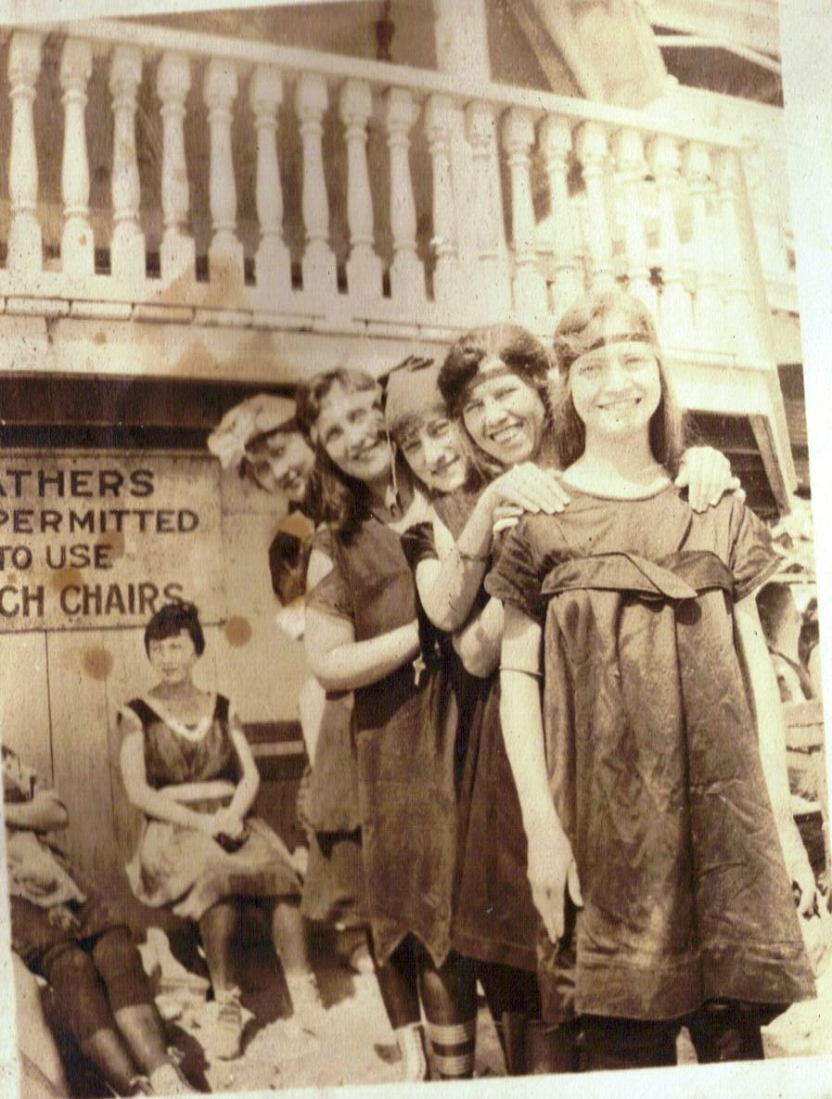

# During this period – between 1913 and 1914 – the family business, Henry Moss & Co, contributed to the building of the [Panama Canal](http://en.wikipedia.org/wiki/Panama_Canal). In Ira E. Bennett’s *History of the Panama Canal, Its Construction and Builders* (Historical Publishing Co., Washington D.C., 1915) “Henry Moss & Co., Machinery, New York City” appears on page 451 listed under “Industrial Role of Honor” (“List of Persons, Firms, and Corporations Who Supplied Equipment from the United States for the Building of the Panama Canal”) You can see this on line. The book is available on Google Books; look on page 451 for the citation.

# 

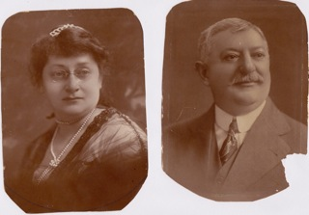

This set of pictures is of Emma Heyderman Moss and George Moss, sometime before 1917 (these pictures are from Ann Buffam; we have copies as well; my grandmother Viola Moss Levinson kept these pictures in frames on her dresser).

Note George’s moustache.

The last President to sport any kind of facial hair was [William Taft](http://www.whitehouse.gov/history/presidents/wt27.html), President from 1909 to 1913. From then on, every US President is clean shaven. In addition, the modern U.S. military started banning beards around the time in question to ensure good seals on modern equipment, such as standardized helmets and, more to the point, gas masks. Something called the “[Clean Living](http://en.wikipedia.org/wiki/Clean_Living_Movements#Progressive_Era_Clean_Living_Movement_.281890.E2.80.931920.29)” movement had also taken off during the late Victorian era, and facial hair had all of a sudden become considered not very sanitary.

In any event, for whatever reason (perhaps thinking ahead just a few months to what would have been his fifty-ninth birthday) on or about Sunday, March 18, 1917 George Moss shaved off his trademark moustache. The story that came down to us is that he must have clipped a growth hidden beneath the hair, which invited an infection which went to his brain and killed him. Indeed the death certificate bears the sad story out.

“Septic cevia due to streptucocic infection of lip possibly from abrasion, not caused by accident.” A contributing cause was septic meningitis. He was attended for three days – from March 18, 1917 (presumably the date of the incident) to March 20, 1917. Time of death was 6 pm. The attending Dr. – Dr. Shea – was of 98 Prospect Park North, and the undertaker Chas. R. Strauss is of 327 Park Place (note the Prospect Park addresses; I had heard that the Moss family had lived for a time in Prospect Park, but if so it’s not become clear when that would have been). George is buried in the “old” [Mt. Carmel Cemetery](http://www.mountcarmelcemetery.com/) in Queens.

My Grandma Vi – who was only 21 when her father George died so suddenly in 1917 – would lament many times in the years to come “If only there had been penicillin back then!” His widow Emma had to quickly go about buying a plot for her husband – the family had none at that time – and she ended up buying a plot for six. No one expected him to die so young; they were all unprepared. George had always joked (according to the story Marcia heard) that when he died he wanted people come to his grave with a bottle of scotch, and pour the scotch over his grave. I wonder if anyone has yet done that!

1917 was the end of an era, not only for our family. Take a look at this post-card. It claims to show the [last horse car](http://www.cable-car-guy.com/images/ny_last_horsecar_001.jpg) in New York, photographed at the corner of Broadway and Bleeker on July 26, 1917.

And here’s a picture of George and Emma Moss’s son Adolph, perhaps from around the same time, taken (according to the embossing the bottom of the photo-postcard) at Otto Ericsson Studios, 461 Fulton Street, Brooklyn:

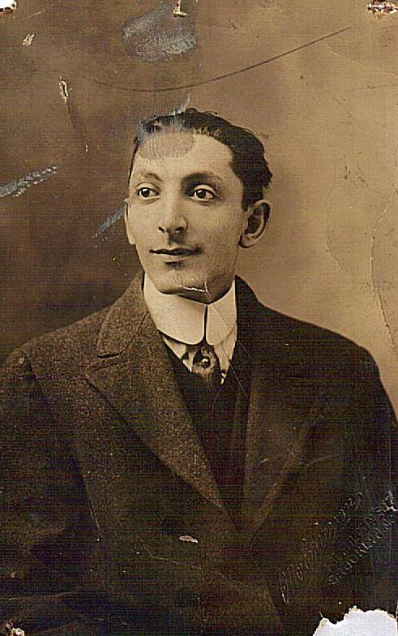

Adolph and his wife Paula Marcus Moss moved around this time to be closer to where Emma was now living with her daughter Viola. Ann Buffam writes:

Shortly after my mother [Roberta, a/k/a Bobby] was born in 1916 on East 9th Street and Ave. J, her parents decided to move to Sterling Street between Bedford Ave. and Nostrand Ave. where Emma Moss was living with Viola, and Ruth and Sam Spanier also had an apartment.  It was there that both Sandy and Donald were born in 1918. By late 1919 or 20 they bought 1580 E. 45th St.

Here’s a picture of Emma and granddaughter Bobby in 1917.

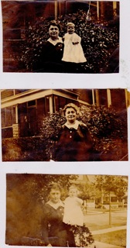

Three pictures of Emma Moss in 1917, holding her year-old granddaughter Roberta “Bobby” Moss Zinn.

And here’s another picture from 1917:

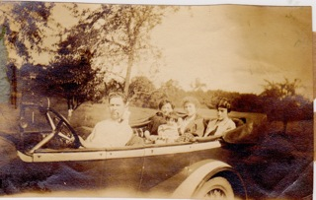

Ruth Moss’s husband Sam Spanier at the wheel with Babette, Bobby, Paula, and Ruth, in 1917. (Picture from Ann Buffam) Sam Spanier, according to Nathan Moss, worked for a time for Benjamin Franklin Moss at Henry Moss & Co.

Here’s a picture of Viola also from around that same time in front of a monument.

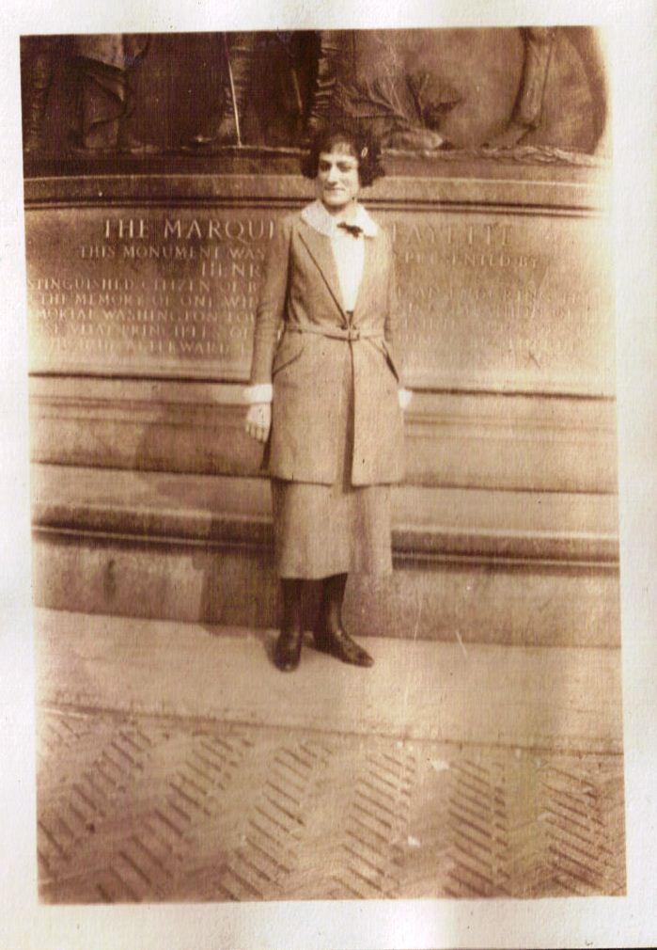

It took a little sleuthing to figure out where exactly this was taken. But [look](http://www.nycgovparks.org/parks/prospectpark/highlights/13307)! It’s the brand new Marquis de Lafayette monument in [Prospect Park](http://www.bridgeandtunnelclub.com/bigmap/brooklyn/prospectpark/lafayette/index.htm) just [dedicated](http://www.hmdb.org/Marker.asp?Marker=30768) that spring, on May 10, 1917.

Benjamin Franklin Moss was remarried at this point to Grace Szerlip (he and his first wife had had no children) and when his wife gave birth to a son they named him George. (Benjamin’s sister Irene would also later name her first born son George.)

# THE BRANDING IRON SCANDAL

Henry Moss & Co had somehow become politically connected, and would manufacture war supplies; articles used in the building of the Panama Canal; sheriff’s badges and police badges for police departments throughout the United States; and hand-cancel stamps for the US post-office. But not without controversy.

A hearing on war expenditures which was held before a select committee of the House of Representatives looked into allegations that Henry Moss & Co had profited unfairly in their dealings with the government during World War I. Look at this. From “War Expenditures: Hearings before Subcommittee No. 5 (Ordinance) of the Select Committee on Expenditures in the War Department, House of Representatives, Sixty Sixth Congress, First Session on War Expenditures, Serial 6, Part 18 (Washington, Government Printing Office, 1919), page 1186:

REPORT TO THE SELECT COMMITTEE ON EXPENDITURES IN THE WAR DEPARTMENT

IN THE MATTER OF HENRY MOSS & CO.

# [PC 29, 30, and 31, and contract No. 1305 – N.]

# The settlement in question arose out of the termination of three informal and one formal agreement. The terminated contracts were entered into on or about September 27, 1918 and provided for the delivery to the United States of 195,000 branding irons at a total cost of $66,716.08. There were delivered under these agreements 2,808 branding irons at a cost of $968.76 leaving 192,192, or a contact price of $65,747.24 to be delivered. The performance of these agreements was suspended on November 18, 1918. Prior to December 28, 1918, contractor filed affidavit of loss, which on January 24, 1919 he refiled as of December 13, 1918.

# You can read this on line. Go to Google Books and look up “War expenditures: Hearings before Subcommittee No. 5 (ordnance ..., Parts 18-33” and then search for Henry Moss & Co. It shows the location as 37 Beaver Street.

# And here’s an excerpt from the…

# “TESTIMONY OF C. P. ABDILL, OFFICER OF THE DIRECTOR OF SALES, WAR DEPARTMENT”

# Mr. Graham: “I will show you a small branding iron, which was contracted for by Henry Moss & Co., and which has been under some investigation by this committee. Do you know whether any contracts for material of that kind have been made since the signing of the armistice?

# Mr. Abdill: “Only one to my knowledge, Mr. Graham.”

# Mr. Graham: “And with whom was that made?”

# Mr. Abdill: “George M. Moss, jr [sic], 61 Fulton Street, New York City.”

The issue seems to have been settled when the president of Henry Moss & Co, B.F. Moss [clearly Benjamin Franklin Moss] released the government from its contract upon receipt of some $44,000. But the bad feelings lingered. Read what the *Amalgamated Sheet Metal Workers Journal,* December 15, 1921, Volume 26, No 12 (Chicago, IL) had to say about Henry Moss & Co. (You can read the entire article on line if you go to Google Books, look up “Sheet Metal Workers' Journal, Volumes 26-27,” and then search for Henry Moss & Co.):

The administration has made a gesture at prosecuting those who robbed the government during the war, and while it is morally certain that none of the big criminals will be rounded up, we ought to wait and see what the government will do before forming final opinions.

The nerve and criminality of the dollar-a-year men who rushed to Washington and took possession of the government, covered in their actions by a disloyal press, surpasses ordinary imagination. A great national calamity would have occurred had the war reached an actually serious stage with such leadership.

On airplanes we spent $1,041,100,000, and when the armistice was signed one year and eight months after our entry into the war no United States airplane had reached the front. The war department spent $1,191,000,000 on guns and only 133 guns had reached the front and were in use when the fighting ended.

For a total of 319,000 horses and mules, dollar-a-year men in the war department ordered 945,000 saddles and over a million sets of double harness and 1,637,197 horse brushes – four brushes for each animal. Nose bags ordered totaled 2,000,000 and halters 2,850,000. In September, when the war was practically over, a contract was made with Henry Moss & Co. of New York for 195,000 branding irons to be made of copper.

Think of the vast perversion of labor and capital which such activities caused…

The Roaring 20’s

A good place to star to get a feel of “The Roaring Twenties” might be [here.](http://www.youtube.com/watch?v=684n8FO68LU&feature=related) Another video takes a look at New York City in [1928.](http://www.youtube.com/watch?v=lkqz3lpUBp0&feature=related)

**THE HEYDERMANS**

Well, there’s one more story to tell about the Heydermans, after which we Moss descendants lose track of them. But the story is unforgettable. It takes place in 1926, and it involves Meier and Auguste “Golde” Heyderman’s widowed daughter Bertha Heyderman Warshauer, and her daughter Dora.

You may remember that Bertha had been married to a man named Max Warshauer, and had been widowed, and that then she and her daughter Dora had lived – according to the 1900 census – with Bertha’s mother Golde and Golde’s new husband Solomon Stone – along with Bertha’s brother Aaron, in Morningside Heights.

Twenty six years later, on Tuesday, October 16, 1926, Bertha and Dora would leave the world together in a dramatic double suicide from the [Martha Washington Hotel](http://www.cardcow.com/images/set102/card00133_fr.jpg) that would be a front-page tabloid story in papers all over the country:

Wednesday, October 27, 1926

2 WOMEN LEAP ELEVEN FLOORS IN DEATH PACT

--

Mother Goes First;

Daughter in Mid-Air

Fights Rescuer

__

(New York World News Service)

NEW YORK, Oct. 27 – Two women, mother and daughter, climbed up and momentarily framed themselves last night in the bright rectangle of a window on the eleventh floor of the Martha Washington Hotel and stepped off into the dimming air to their deaths.

They were identified as Mrs. Bertha D. Warschauer and her daughter Dorothy, aged about 50 and 30 respectively.

The women made their way through the crowded lobby to the desk about 5 o’clock and told the clerk, John Campbell, that they wanted a room.

“High up, please,” said the younger. “We want an outside room with fresh air.”

Campbell rang a bell and called “Front!” The bellhop observed that the women had no luggage. When they reached room 1101, the women went inside, the bellhop waiting

in the hall.

The elderly woman, well but quietly dressed, strolled to the window and looked out. The room was in the middle of the building, which brought the window directly over the sign below.

“All right,” she nodded to the younger.

“That’s all then,” said the younger woman to the bellhop with a bright smile.

“But you’ll have to register,” was his reply. “I can’t leave you the key without you register.”

“I’ll go down mother,” said the young woman, seeming in high spirits. And she accompanied the boy to the desk and wrote on the sheet:

“Mrs. Walsh and Miss Walsh, Boston, Mass.”

“Initials?” inquired Campbell dubiously.

“Must I put them down?” she asked.

When he said yes she inserted the letters B. and D., for Bertha and Dorothy. Then the bellhop conducted her back to room No. 1101 and he noticed the elder woman had already removed her coat.

Twenty minutes later Miss Virginia Bixby in room No. 1104 heard a splintering, glassy sound outside her window and rushed to the sill, thinking there had been an automobile collision. At the same time Miss Marjorie La Plante of Toronto, emerging from her bath in room No. 902, heard a thud at her open window.

“I saw what had made the crashing sound,” said Miss Bixby. “There was just enough light to see a dark splotch, like an outstretched body, caught on the entrance canopy far below. And on the ninth floor ledge, another woman was hanging half over and fighting with somebody inside who was trying to keep her from falling.”

The younger woman had not jumped clear of the narrow grillwork outside the windows and had caught two floors down.

Miss La Plante, a slight girl, held on grimly and tugged with a slipping hold.

“You fool!” screamed the girl in her arms. “Let me loose, you fool! I want to go to mother.”

Miss Bixby took in the scene at a glance and, throwing on a kimono, ran out her door and raced down the steps at the end of her corridor. But she miscalculated the depth below her of the little melodrama and brought up outside the door of room 802 instead of 902. She pounded with her fists and got only an echo from inside.

It dawned upon her she was too low. She Ran back a flight. Door 902 was locked. She heard the same voice scream:

“Let me loose, you fool, or I’ll take you along!”

There followed a little silence and another splintering jar and a moment later Miss La Plante unlocked her door and collapsed in the arms of Miss Bixby, blood running from her throat where the suicide had scratched her.

Both women went to the window and looked out sickly. Dimly below, on the chains which braced the electric lighted canopy to the wall, they could see two bodies.

Police could not retrieve the bodies. Firemen finally lifted the dead women into room 201, just

over the canopy. When the medical examiner arrived, he found in the pocket of the mother’s coat, left upstairs, a card from Dr. Dora A. Bass of Brooklyn. Dr. Bass gave the name of Dr. H. Schumann of Brooklyn, and both said they had

been treating the young woman.

The police said Miss Warschauer had been treated recently at the Central Islip State Hospital for the Insane.

You can read a copy of the original article [here](http://news.google.com/newspapers?nid=2206&dat=19261027&id=ID0uAAAAIBAJ&sjid=htcFAAAAIBAJ&pg=6592,279287). The story also appeared in St. Petersburg, Florida’s [The Evening Independent](http://news.google.com/newspapers?nid=950&dat=19261027&id=mewLAAAAIBAJ&sjid=1VQDAAAAIBAJ&pg=1469,13009), Ames, Iowa’s [Ames Daily Tribune](http://www.newspaperarchive.com/SiteMap/FreePdfPreview.aspx?img=100440378) and Cumberland, Maryland’s [Cumberland Evening News](http://www.newspaperarchive.com/SiteMap/FreePdfPreview.aspx?img=102531495). The account in the Cumberland paper includes the detail that written on the card with the doctor’s name was a note: “Brother knows all about the money.” In the Ames paper, it said “A note left behind said ‘Notify A. Heiderman, he knows about jewels and money.’ Heiderman was found in Brooklyn. Mrs. Warshauer was his sister, but he could throw no light on the tragedy.”

**THE MOSS FAMILY**

In the 1920’s the six Moss siblings – brothers Benjamin Franklin, Samuel H, and Adolph; and sisters Irene, Ruth, and Viola – were now all adults and making their way in the world. The sisters were close, and would remain so all their lives. The brothers not so much.

Henry Moss & Co. was now in the hands of Henry’s nephews Benjamin Franklin and Samuel H (Nathan Moss told me that his father Benjamin Franklin Moss had bought uncle Henry out), although there seems to have been a power struggle between Benjamin Franklin and Samuel H. and they would ultimately separate – leaving the business in Ben’s hands, while Sam went off to found his own stamp-making company, Samuel H. Moss, Inc. (Nathan says his father accused Sam of stealing their clients and setting up his own business; Sam’s daughter Marjorie is not here to tell her father’s side of the story.)

Adolph, always the frail one (he had had scarlet fever as a child) worked for Henry Moss & Co. only for a while. In any event, he would end up selling cars for a living, and then took an office job, as the executive secretary at Union Temple.

Here’s a picture of Adolph (seated, third from the left) and his sister Ruth (on the right)

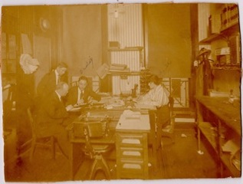

Ruth Moss Spanier working with Adolph Moss and two unidentified men. “Daddy” is written above Adolph’s name, we assume by Adolph’s daughter Roberta “Bobby” Moss Zinn. The picture was perhaps taken in the late teens or early twenties. (Picture from Ann Buffam).

About this picture Ann Buffam writes:

|  |
| --- |
| “When Adolph married Paula he was working for Henry Moss and Co. And I am  guessing that's where that office photo was taken.  My mother said, ‘No one today  seems to know (the occupation of Pop Moss)! They only tell me he was fond of his  scotch. He died when I was about 3 months old from an infection from a picked pimple  on his face...no penicillin in those days.’   What a memory to leave us!” She added “I  am only deducing this from 1. what my mother wrote in her essay  2. the approximate  date of the photo. If the photo is later than 1916-17 then Ruth would have to be  working with Adolph in his business selling cars... and somehow the photo doesn't  suggest that...but I don't really know.  Maybe your mom would know.” |
| Benjamin Franklin Moss’s son Nathan Moss would later tell me the same about George “Pop” Moss – that no one knew what he did. Nathan thought he might have been a clothing salesman (Nathan’s daughter Selma had heard that the family was connected to an English clothier; perhaps Moss Bros., founded in 1851 <http://www.mossbros.com/aboutus/aboutUs.htm>). |

Below is a picture that Ann Moss Buffam had of her mother Roberta (Bobby), Bobby’s Aunt Irene, Irene’s son Georgie, and another uncle and cousin on Bobby’s mother’s side.

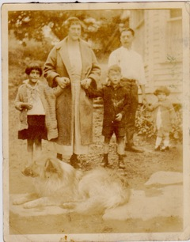

Roberta (“Bobby”) Moss Zinn, Irene Moss Strumph, and Irene’s son Georgie, 1926 (from Ann Buffam)

Ann wrote:

“Mid to late 1920’s: Here's the one of Bobby (although it really doesn't look like her, yet my mother labeled it), Irene and Georgie.  The man in the back is Milton who was married to Paula's sister, Stella, and that is his daughter, Shirley.  The photo was taken in the mid to late 20's at Baumgarten's, a farm holiday place in Connecticut.  They all went there a number of times.  And the most often told story is that Uncle Ira loved the chickens, and was appalled when one of his ‘pets’ was served for dinner.  He refused to eat.  He was probably about 4 years old then.”

In 1920 Emma Heyderman Moss was 56, three years widowed, and was, according to the [1920 census](https://familysearch.org/pal:/MM9.1.2/MN47-KS1/p_433221283), living with her daughter Irene Strumpf, 29 (pictured above), Irene’s husband Edward Strumpf, 31, and their little son George, 2 ½; along with Emma’s unmarried daughter Viola, 23 (Vi would not marry until she was 31).

Emma – so Marcia Levinson Sameth had heard - was very active in the life of her Reform congregation in Park Slope. She had her own copy of the “Union Prayer Book” (Cincinnati, 1923 – later to be known as the “Old” Union Prayer Book) with her name embossed in gold letters, which passed to her daughter Ruth, Ruth’s son Donald, and is now in the possession of Donald’s son Bob Spanier:

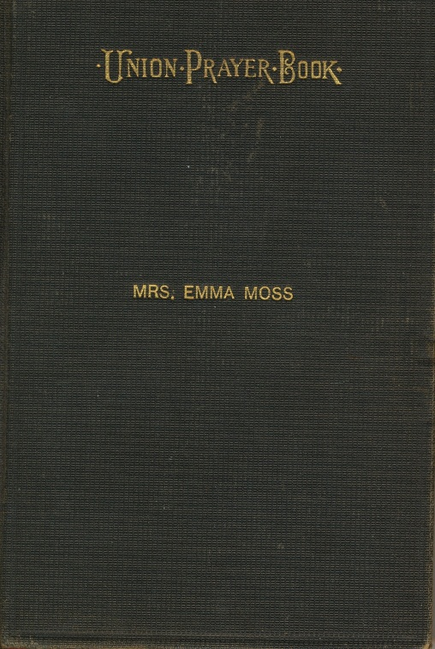 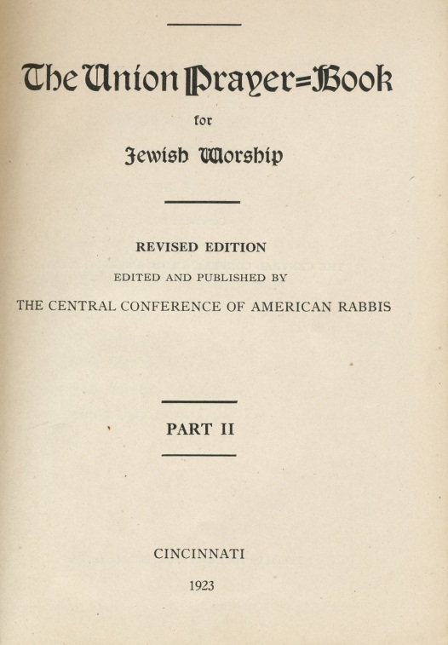

One might think, following the bad publicity coming out of the World War I Branding Iron Scandal – a congressional investigation, no less! – that the Moss family business might have suffered. Apparently not. Henry Moss & Co. in the 1920’s was successfully manufacturing and selling licensed chauffer badges, sheriff’s badges, and other official items to buyers as far away as Texas.

|  |
| --- |
| Here’s a Texas Chauffeur badge dated manufactured by Henry Moss & Co. in 1923. “Shield shaped nickel plated brass 38.6 mm wide and 41mm tall made by ‘Henry Moss & Co 353 R. St. B’klyn. N. Y.’ as marked on the base of the pin. The badge is in nice used condition but the pin is corroded and is missing the catch... This is a scarce badge listed in the John Connors’ book with a valuation of 130.00.”  [Texas 1923 Chauffeur Badge Genuine](http://freds.ecrater.com/p/10570965/texas-1923-chauffeur-badge-genuine) |
| [http://s.ecrater.com/img/zoom_icon.gif](http://freds.ecrater.com/p/10570965/texas-1923-chauffeur-badge-genuine) |
|  |
|  |
| |  |  |  |  |  | | --- | --- | --- | --- | --- | |  |  |  |  |  | |



|  |  |  |  |  |  |  |  |  |  |  |  |  |  |  |  |  |  |  |  |
| --- | --- | --- | --- | --- | --- | --- | --- | --- | --- | --- | --- | --- | --- | --- | --- | --- | --- | --- | --- |
| Here’s a [link](http://freds.ecrater.com/p/10570965/texas-1923-chauffeur-badge-genuine) to read more about this badge on-line.  The next year, 1924, was a big year for Henry Moss & Co of Brooklyn, N. Y. In June of that year they received a government contract for the manufacture of the U.S. Postal Service’s rubber pre-canceling hand-stamps for the next two fiscal years. The government had begun issuing contracts for these in 1915. That year it had gone to H. Baumgarten Company of Washington, D. C. I mention that name only because the Moss family would spend their summers at a Connecticut resort called “Baumgarten’s.” Possibly a coincidence; or possibly these families knew each other. (In any event, you can read more, an article on the history of Precancel Stamps, in the Appendix.)   |  |  |  |  |  |  |  |  |  |  |  | | --- | --- | --- | --- | --- | --- | --- | --- | --- | --- | --- | | And here’s an item from the following year, 1925. The description on line read “This auction offers a 1925 New York Chauffeur License brass pin.  Badge number is 596595 and expired on July 1, 1925.  On back is stated "Henry Moss & Co Inc. 113-538 ST BKLNY, NY.”  This pin is in good shape with original back screw type washer.  Nice Find!! | | |  |  |  |  |  | | --- | --- | --- | --- | --- | |  |  |  |  |  | | |  | | |  | | | | | |  |  | | --- | --- | | Top of Form  Bottom of Form   |  | | --- | | 1925 Chauffeur License Pin - New York - Brass | | | |   And here’s a [link](http://www.ebay.com/itm/1925-Chauffeur-License-Pin-New-York-Brass-/130569122848) to this badge as it appeared on e-bay  Here’s another badge manufactured by Henry Moss & Co. that also turned up on e-bay. The description read: “RARE Vintage obsolete New York City Department of Corrections Keeper badge number 691. Badge is approx 3" x 2 & 1/4". Badge made by Henry Moss & co. inc. Brooklyn New York.  Pin is original to this badge. THIS BADGE IS AT LEAST 75 YEARS OLD AND DOES NOT VIOLATE EBAY POLICY.  This badge is unconditionally guaranteed as original.  Buyer has a 7 day inspection and return privilege as long as badge is returned in the same condition as sent.”  [http://img.auctiva.com/imgdata/5/5/5/2/0/3/webimg/495790626_tp.jpg](http://www.auctiva.com/hostedimages/showimage.aspx?gid=555203&image=495790626&images=495790475,495790626,495790510,495790494,495790530,495790650,495790561,495790581,495790544&formats=0,0,0,0,0,0,0,0,0&format=0)[http://img.auctiva.com/imgdata/5/5/5/2/0/3/webimg/495790544_tp.jpg](http://www.auctiva.com/hostedimages/showimage.aspx?gid=555203&image=495790544&images=495790475,495790626,495790510,495790494,495790530,495790650,495790561,495790581,495790544&formats=0,0,0,0,0,0,0,0,0&format=0)  A link to that site is [here.](http://www.ebay.com/itm/VINTAGE-NEW-YORK-CITY-DEPT-CORRECTIONS-KEEPER-BADGE-/290597049657) |
| http://s.ecrater.com/images2/px_blank.gif |
|  |
|  |

So that takes us to 1927. In 1927 [Henry Moss & Co., Inc](http://www.google.com/search?hl=en&tbm=bks&tbm=bks&q=inauthor:%22Henry+Moss+%26+Co.,+Inc%22&sa=X&ei=UY6xTqCcGuP10gGLsZniAQ&ved=0CDUQ9Ag) published a 99 page book called “Rubber Stamps;” along with fabrication of metal items, rubber stamps had been an important part of their business. When Benjamin Franklin and Samuel H ultimately split the business, Sam would trade heavily on his expertise in rubber stamp manufacturing.

1927 was also a big year for my Grandma Vi. At 31, she was finally to be married. At their 50th Wedding Anniversary party held at Ridgeway Country Club in White Plains, NY just before Meyer died in June, 1976) Vi’s nephew Ira Moss told a hilarious rendition of how she and my Grandpa Meyer had met at a Catskills singles weekend; something about Meyer being on a hay-ride, and Vi running along the road trying to catch up!

However that meeting actually took place, in 1927 Viola Moss and Meyer Levinson were married. At that point her mother Emma – with whom she had been living on Sterling Street, between Bedford and Nostrand, according to Ann Buffam - moved in with daughter Ruth, and Ruth’s husband Sam Spanier, in their home at 2051 East 41rst Street, Brooklyn. Ruth and Sam had the front bedroom; Emma had the back bedroom; and Ruth and Sam’s son Donald Spanier had the very narrow bedroom, further in the back. The six Moss children were now all married. Everyone was finally settled. And then the market crashed.

Great Depression: The 1930’s

**THE MOSS FAMILY**

“The depression originated in the U.S., starting with the fall in stock prices that began around September 4, 1929 and became worldwide news with the [stock market crash](http://en.wikipedia.org/wiki/Wall_Street_Crash_of_1929) of October 29, 1929 (known as Black Tuesday). From there, it quickly spread to almost every country in the world.” ([Wikipedia](http://en.wikipedia.org/wiki/The_Great_Depression).)

The Great Depression – a time of scarcity, deprivation, fear and uncertainty – set the context for everything that was to come over the next years.

1931 was, in the life of our family, a momentous year. On March 16, 1931, Viola gave birth to a baby girl, Marcia Jane Levinson, who was the youngest and last of George and Emma Moss’s grandchildren. There was celebration. But just a few months later, the family was in mourning over the untimely death of George and Emma’s son Adolph. Here’s a picture of Adolph and his wife Paula Marcus toward the end of his short life:

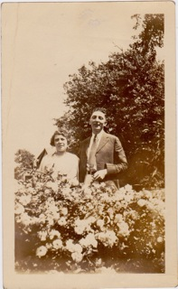

*Adolph Moss and his wife Paula Marcus Moss, 1930 or 1931. (Picture from Ann Buffam)*

Emma – who had suffered the untimely death of her husband George (1917); the double suicide of her sister Bertha and niece Dorothy (1926) – now suffered the death of her youngest son.

Adolph had been the treasurer of the Brooklyn Jewish Center, and had worked for [Union Temple](http://www.uniontemple.org/aboutus/history/) – created through the 1921 merger of two large Brooklyn Reform temples: Temple Israel and *Kahal Kodesh Beth Elohim* - as their executive secretary. It seems he also worked for Henry Moss & Co for a while; but that had been a long time ago. He was not involved in the falling-out presumed to have taken place between his older brothers Benjamin Franklin and Samuel H. The Moss family, according to Marcia, did not belong to Union Temple, but rather to another synagogue in Prospect Park, [Congregation Beth Elohim](http://en.wikipedia.org/wiki/Congregation_Beth_Elohim_%28Brooklyn,_New_York%29) (not to be confused with the aforementioned *Kahal Kodesh Beth Elohim.* Notwithstanding any of this, during the Depression Marcia was herself confirmed at *Ahavas Shalom*, a Conservative *shul* which was closer their home, known as “The Avenue R Temple” at East 16th.)

As has been mentioned, Adolph had had scarlet fever as a child, and died of endocarditis – a very painful death – in the house he shared with his wife Paula Marcus Moss, and their three children: Ira, Sandy, and Bobby (Roberta). The funeral took place on August 11, 1931 at Union Temple House.

Here’s the obituary, which ran in the *Standard Union*:

*Standard Union*, Tuesday, August 11, 1931

Deaths in the news  
  
FUNERAL TODAY FOR ADOLPH MOSS  
Funeral services will be held this afternoon at 2 o'clock in the Union Temple House, 17 Eastern parkway, for Adolph M. MOSS, treasurer of the Brooklyn Jewish Center and executive secretary of the temple. Mr. MOSS died Sunday at his home, 1580 East Forty-fifth street, in his fortieth year. He was a prominent Brooklyn civic and church worker. He was the son of the late George MOSS. He is survived by his mother, Mrs. Emma HAYDERMAN MOSS; his widow, Mrs. Paula MARCUS MOSS; a daughter, Roberta; two sons, Sanford and Ira MOSS; three sisters, Mrs Irene STRUMPH, Mrs. SPANIER and Mrs. Viola LEVINSON, and two brothers, Ben and Sam MOSS.

(Note that “Hayderman” is incorrect - it was spelled Heyderman, and pronounced HIGH-der-man. An abstract is available on line from [Brooklyn Genealogy.](http://www.bklyn-genealogy-info.com/Newspaper/BSU/1931.Death.Aug.html) )

And then Emma took ill in late December, 1931 and died on January 2, 1932. This is why, Marcia told me, New Year’s was always a difficult time for the family; that they could never celebrate it. Emma died on January 2, 1932 in their home at 2051 East 41rst Street, Brooklyn. The cause of death was listed as colon cancer and myocarditus; duration 3 days. She was buried next to George in the old Mt. Carmel cemetery on January 4, 1932.

Here are some pictures of Emma taken in the latter part of her life:

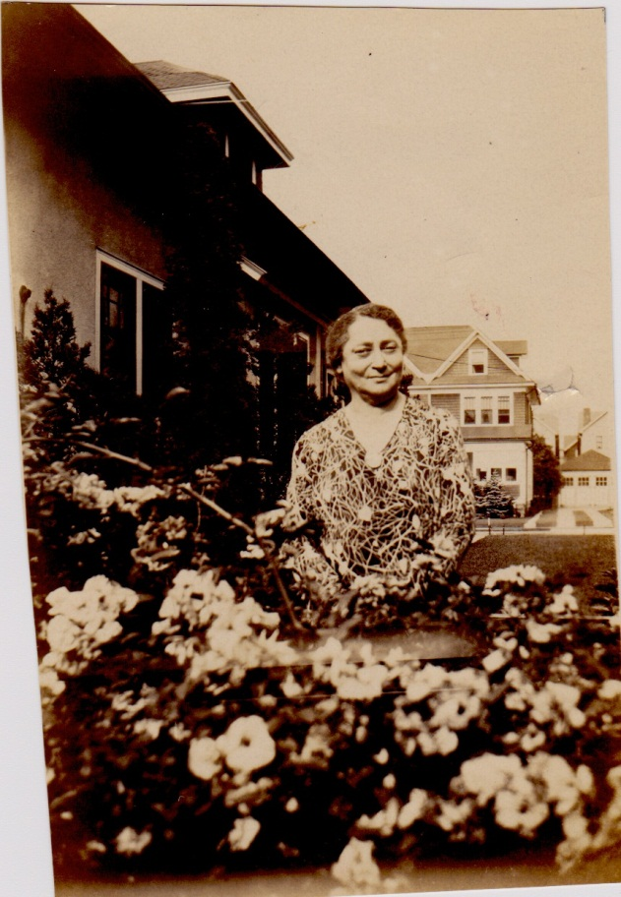

Emma Heyderman Moss at the home of her daughter-in-law Paula Marcus Moss, 1580 E. 45th Street. (Ann Buffam)

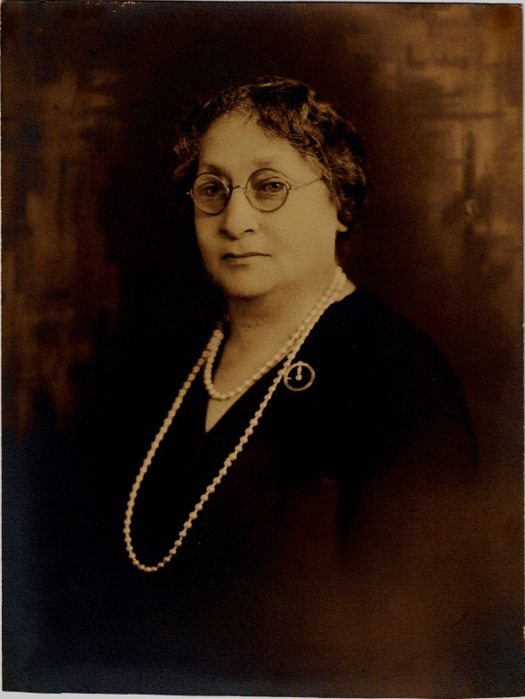

A formal portrait of Emma from perhaps around the same time. (Marcia Levinson Sameth)

Times were hard, and for a while Meyer, Viola, and their young daughter Marcia moved to Tioga, Pennsylvania where Meyer had worked with a cousin as a young man. But eventually they came back to Brooklyn and settled into an apartment house near PS 119 in Brooklyn. Marcia remembers sitting in her little rocking chair (she still has it) listening to “Uncle Don” on the radio.

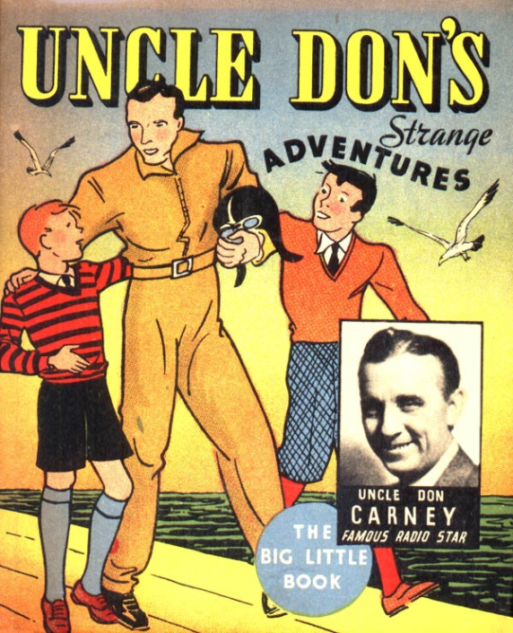

Marcia remembers that her mother Viola gave her a lifesaver candy once, which she then choked on. Another time Marcia was sleeping in her crib; she woke up and realized her parents had stepped out (probably for only ten minutes she says) and she was there crying all alone.

Henry Moss & Co seems to have thrived, even during the Depression. Here’s an example of their work from the mid-1930’s:

[[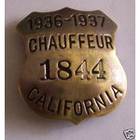](http://images.cloud.worthpoint.com/wpimages/images/images1/1/0708/13/1_774e8c5f0e7780336bc8400044d7e07c.jpg)](http://images.cloud.worthpoint.com/wpimages/images/images1/1/0708/13/1_774e8c5f0e7780336bc8400044d7e07c.jpg)Vintage 1936-1937 California Chauffeur License Badge

Up for auction is an original, vintage, hallmarked and numbered 1936-1937 California Chauffeur License badge. This badge is in good condition, showing wear of the silver or chrome plate on the badge. This is an obsolete badge, with the pin and clasp in very good condition. The badge is hallmarked Henry Moss & Co. of Brooklyn, N.Y. and is numbered "1844" on the front. The badge is approximately 1.5 inches high by 1.5 inches wide. Buyer pays shipping and handling of $3.55. Thanks for looking!!

But for others in the family, the Depression threatened financial ruin. In 1935 or ’36 Ruth Moss Spanier her husband and Sam Spanier were in danger of losing the house on 41rst Street. Sam’s sister – our Aunt Anna and Anna’s husband Ralph – lived down the street, with similar worries. Meyer, Viola, and little Marcia moved into the house on 2051 East 41rst Street.

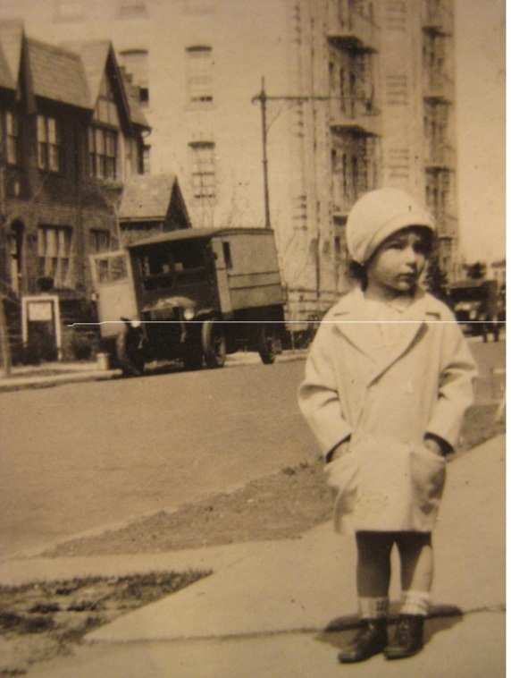

Sam and Ruth had the bedroom in the front. Their son Donald had the narrow bedroom in the back of the house. Meyer, Viola, and Marcia took the bedroom that had been Emma’s. (Marcia would live in her parents’ bedroom until her cousin Donald went off to war.)

Viola had only gone through the 8th grade. But owing to the fact that she had gone so long as an unmarried “career woman,” Vi had picked up a valuable skill. She knew how to operate a comptometer (pronounced com-TOM-a-ter). A comptometer was an early version of the calculator. Vi got herself a job at one of the insurance companies in the Wall Street area of Lower Manhattan, and that income saved the house.

Here’s a picture of a [comptometer.](http://en.wikipedia.org/wiki/Comptometer)

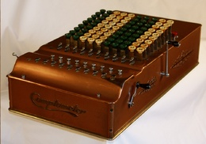

The 1940’s

Sunday, December 7, 1941: Two of the three Moss sisters, Ruth and Viola, their husbands Sam Spanier and Meyer Levinson and Meyer and Vi’s young daughter Marcia were sitting in the living room of the row house they all shared on East 41rst Street - reading or perhaps listening to the ballgame on the radio - when suddenly Ruth and Sam’s son Donald came running down from his upstairs bedroom. “They just bombed Pearl Harbor!”

The next day, Monday, December 8, 1941, Donald – who was eighteen years old at the time - signed up for the war. (Marcia remembers that - as a ten year old who had been living through the Depression in her parents’ bedroom from the age of about 4 or 5 - she desperately wanted her own room. Yes, her Aunt Ruth told her, you can have Don’s room… just not the first night he’s gone.)

Cousin Sandy Moss (son of the late Adolph Moss and Paula Moss) was at Paula’s house nearby. He signed up as well. A B18 was manned by ten men; Sandy was trained as the flight engineer, the one who traced the route of the plane.

Sandy’s younger brother Ira would also sign up. Ira was in the Engineering Corps, and would later joke about how spent the war carrying a bridge all across Germany. They would set it up, and take it down; set it up and take it down.

Sandy and Ira’s sister Bobby’s husband Arthur was, at the time, in either already in the service, or just getting ready for service as well.

Charlotte and Donald were already going together. He would soon be going overseas, and they made the most of the time they had together. Here’s a program from a Dodger’s game at Ebbets Field they attended presumably in the early spring of 1943:

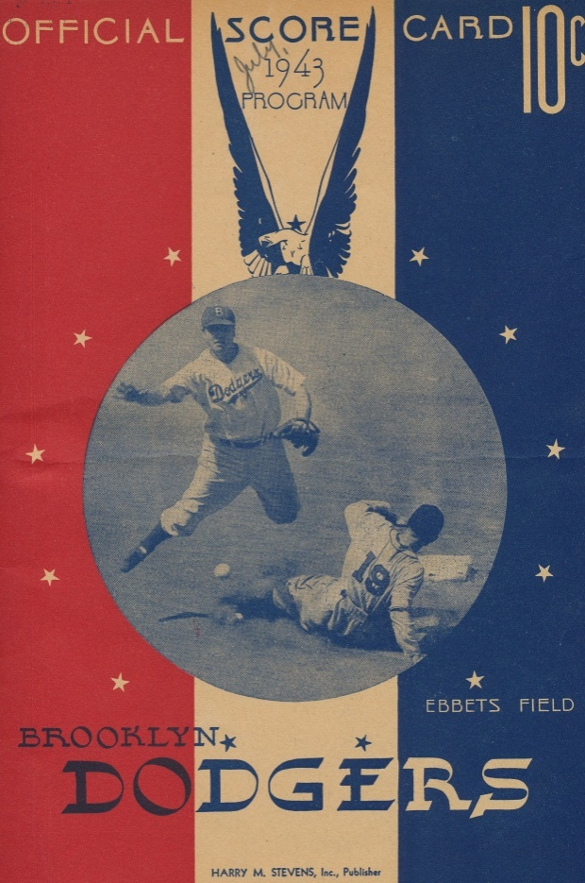

Charlotte followed him to Walla Walla, Washington which is where he did his training as a bombardier; and then they married there on July 3 1943, just before he shipped out. Here’s a picture of Charlotte and Don on their honeymoon:

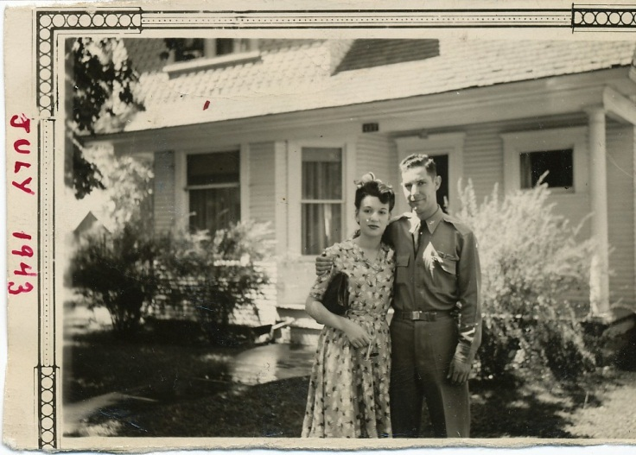

Donald flew thirteen missions over Europe in a B-17 as an Army Air Corp bombardier until he was shot down on December 20, 1943. He spent a year and half as a prisoner of war. Here are his two “mug shots” that he kept in his journal:

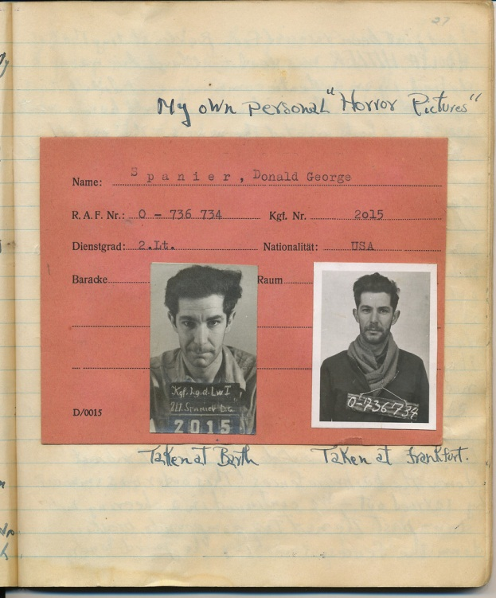

To see the telegram from the War Department reporting Donald missing (and subsequent letters and telegrams reporting him a Prisoner of War) go to the [web-site](http://warfragments.weebly.com/status.html) set up by his son Bob. There’s another page on the site with [pictures](http://warfragments.weebly.com/pictures.html). Excerpts from his journal are also on line.

There’s a story that does not appear in the journal, but that my mother Marcia Levinson Sameth remembers Donald telling. It has to do with the very last days of the war. He and his fellow prisoners knew from their American commander that the camp was about to be liberated. The Nazis knew it too. At morning line-up, which would take place outside the barracks, the Nazi commander ordered all of the Jews to step forward. But at that moment, as the American commander had prearranged with his men, all of the prisoners stepped forward as one. It sounds like a scene from a movie – indeed, such a scene appears in the movie *Berga: Soldiers of Another War* (see Appendix VI below) – but Marcia is absolutely certain that this is the story that Donald told. (Berga took place at Stalag 9B, northeast of Frankfurt, Germany; Donald was a prisoner at Stalag Luft 1, in Barth, Germany.)

Marcia’s future husband Marvin was only 14 years old when Pearl Harbor was bombed, but he too would sign up before the war’s end. Stationed at first on the Great Lakes between Chicago and Milwaukee and after that at Long Beach, he would later joke that he spent WWI on an island 3,000 miles from San Francisco: Long Island.) Only a few months after Marvin turned eighteen the war was over. VE Day ([Victory Day in Europe](http://en.wikipedia.org/wiki/Victory_in_Europe_Day)) was May 9, 1945. VJ Day ([Victory Day in the US](http://en.wikipedia.org/wiki/Victory_over_Japan_Day)) was August 9, 1945.

Neither of Benjamin Franklin Moss’s sons joined the service. His younger son Nathan had had polio as a boy and was 4F. His older son George – who was old enough to have gone – was deferred. The family business – which included making metal signage to be used aboard navy ships - was deemed necessary for the war effort. Nathan and George, their father Benjamin Franklin Moss, and their Uncle Samuel H. Moss (with three separate but similar businesses) all did very well during the war. “It was a lucrative business,” Nathan told me when I visited him in the nursing home in the spring of 2012.

By this time Benjamin Franklin Moss and his brother Samuel H. Moss had split (an echo, perhaps, of the death of Theodore Moss & Co. and its rebirth as Henry Moss & Co. in 1905?) Sam had the Samuel H. Moss stamp business on 23rd Street, just off of Union Square. He and his wife Marjorie would eventually move into an apartment on Park Avenue. Years later (in 2011 when I was piecing this story together) I spoke to Peter Berlin, who had been hired by Samuel H. Moss back in 1965. He said that Sam had been a very nice guy, who had lived at 80 Park Avenue with his wife Lillian May Moss. They had one daughter Marjorie who married Robert Raphael (both deceased) and that Marjorie and Robert had had one son Ronald Raphael who lives on 16th Street in NYC with his wife Carol. After Lillian died, Peter told me, Sam moved next door to the Raphaels, which is where he died in 1976. Peter also answered a question I didn’t know I had: What had the “H” in Samuel H. Moss’s name stood for? The “H” Peter told me was for “Hyde” - a family name, according to Peter, that echoed Sam’s mother’s maiden: Heyderman. The Samuel H Moss stamp company is now part of a group of 7 stamp companies bought up by [Krengel Mfg. Co](https://www.samuelhmoss.com/AboutUs.aspx?showpage=2). for whom Peter now works, but the [Moss](http://www.thesamossgrp.com/UI/en-US/Catalog/Sam%20Moss%20-%20uC) name was retained.

I met Ron Raphael – Samuel H. Moss’s only grandson – and his wife Carol in 2012. They live directly across the street from [The Center for Jewish History.](http://www.cjh.org/) Ron was 73 years old at time, six years retired from the Samuel H. Moss business, living at 16 West 16th Street, NYC. Ron told me:

Sam spoke very little about the family. Sam had started out working for his Uncle Henry. Henry Moss & Co had been at the 23rd Street location. It was “the store under the stoop” (ie, in the basement) but later he moved it to the second floor. I also heard the story about Henry Moss & Co. working on the Panama Canal. In any event, at some point there had been a falling out between Sam and his brother Benjamin Franklin Moss, about what I do not know. *Much was withheld.* I think Sam wanted to be independent of the whole family. The only one of Sam’s siblings I remember hearing about was Viola. Anyway, after the falling out Sam started Samuel H. Moss, Inc. at the same location on 23rd Street. They made rubber stamps, nameplates, and later other signage. Their biggest customer was Con Edison. They made date-stampers for them (to show what time something was received). They also made nameplates for warships during WWII: “Captain’s Quarters” etc.

Ron told me that Sam’s wife, Lillian May, was American born, but her family was from Alsace Lorraine (Germany at one time). They had one child, Marjorie, who had married Robert Raphael; Ron was their only child. They lived on Sterling Place in Brooklyn until 1961 when Ron was in the 8thh grade, and then they moved to the city. Marjorie died in 1990; and Robert in 2000. Sam and Lillian moved to the city a few years later, maybe 1964, and lived on Park Avenue; the Raphaels on Riverside and 73rd. Ron married Carol, and they have one daughter, Lisa, who lives in Jacksonville FL and has three children. She is remarried; her husband’s name is Christian.

The Samuel H. Moss Rubber Stamps business passed to his daughter Marjorie. Her husband Robert Raphael worked there; and Ron did as well, for forty years. He retired around 2006. Sam Moss, Ron told me was a very quiet, reserved person, conservative in dress and demeanor. He was a loving person, whereas Lil was more aloof, and Ron remembers him with great affection. He enjoyed being “higfalutin” and would take them to fancy restaurants. But he never put on airs, Ron said. He liked to play cards: gin and pinnacle. And there was a Mah Jong phase. He’d play with the boys; the girls played separately. He lived to be 93 and so he met his great-granddaughter Lisa. He was cremated and his and Lil’s remains are at Woodlawn. Like the rest he was highly assimilated. But he did go to High Holiday services every year at Garfield Temple. They went to a place called Hahn’s in Connecticut in the summer; maybe near Darien? A very nice guy.

The public record gives a different impression. Samuel H. Moss’s *Samuel H. Moss Rubber Stamps* was sued by the Federal Trade Commission for predatory pricing:

The defendant Samuel H. Moss, Inc. was engaged in the business of processing, manufacturing, offering for sale, selling and distributing made to order straight line rubber stamps. These stamps were primarily sold directly to consumers and were sold generally through competitive bidding. Defendant, a firm located in New York City, sold to customers as far away as Chicago, thus the relevant market area seems to have covered several states at least.

The charges against the defendant, while rather extensive as presented in the record, were in essence the following. Defendant was accused on (1) selling rubber stamps to certain customers at lower prices than those charged others, (2) offering to sell at least eight of these in particular at prices substantially below those charged by the firms previously supplying these eight customers, and (3) taking the trade of these eight customers for the firms previously supplying them with rubber stamps….

The court found for the FTC. (From *Predatory Pricing in a Market Economy* by Roland H. Koller, page 152, on Googlebooks.)

In the 1940’s Benjamin Franklin Moss continued to live in what can only be described as baronial splendor in a house on Ocean Parkway. His son Nathan said that Benjamin Franklin Moss had bought the mansion in 1930; that it had a billiard room/library; a “playroom;” and a room for the servant to sleep in. Nathan’s daughter Selma Moss-Ward remembers visiting there (after Benjamin Franklin Moss had passed away, and Grace had remarried). She, and my mother Marcia, have similar memories of it: heavy, hand-carved wood furniture; animal heads mounted on the walls; beer steins; and “colored” servants as they were called in the day: a man who served as chauffer and butler; a woman who cooked, cleaned, and served.

The company was repeatedly sued. See “Application of Walling, 47 F.Supp. 255 [1942] Application of WALLING, Administrator of the Wage and Hour Division, United States Department of Labor, Misc. No. 729, District Court, E. D. New York, October 13, 1942, Irving J. Levy, Acting Sol., of Washington, D. C., Arthur E. Reyman, Regional Atty., and William E. Sullivan, Associate Atty., U. S. Department of Labor, both of New York City, for the motion. Lothair H. Szerlip, of Brooklyn, N. Y., for Henry Moss & Co., Inc., opposed.) .

See also Hurwitz v. Henry Moss & Co., New York City Ct, 1944, 49 N.Y.S. 2d 106. (*United States Code Annotated*, West Publishing Company, Edward Thompson Company, 1998, at books.google.com). A Tax Code memorandum decision in 1946 indicates that “Moss Industries began business on January 1, 1946, as successor to Henry Moss & Co., a partnership dissolved at the close of 1945. Henry Moss & Co., the partnership, was successor to Henry Moss & Co. Inc., which ceased doing business In 1942 ...” (see TC memorandum decisions, volume 22, [United States. Tax Court](http://www.google.com/search?tbo=p&tbm=bks&q=inauthor:%22United+States.+Tax+Court%22), [Prentice-Hall, Inc](http://www.google.com/search?tbo=p&tbm=bks&q=inauthor:%22Prentice-Hall,+inc%22)., 1953, at Googlebooks.) At the time of its dissolution, the stock of Henry Moss & Co. had been controlled by Benjamin Franklin Moss, and his brothers-in-law Lothair, Arthur Szerlip, and Sidney Szerlip.

Need we say it? That after Benjamin Franklin Moss’s death more lawsuits followed? There was Szerlip v. Crown Enters. Inc. 277 A.D. 1060 (1950) Lothair H. Szerlip,, Respondent v. Crown Enterprises Inc., et al., Appellants, and Moss Industries, Inc. et al, Respondents. And there was Kearny v. Smith, January 2, 1986 (Plaintiffs instituted this action for damages with the filing of a complaint on February 6, 1985 alleging libel and slander against an exceedingly large number of defendants. By order dated July 11, 1985 we dismissed the complaint against defendants Seymour H. Chanin, Geoffrey E. Chanin, Lothair H. Szerlip and Unibay Co., Inc. *for lack of subject matter jurisdiction.*)

Read it and weep.

In the spring of 2012 I went to visit Nathan Moss at a nursing home on Staten Island. I asked him about the stories of the family’s crimes. Had heard the story that the family had hidden money in a mausoleum? That one was not true, Nathan told me (although he admitted to having heard the same rumor regarding the Szerlip Mausoleum, Acasia Cemetery, in Queens where Benjamin Franklin Moss and wife Grace are buried). But no money had been hidden there, he insisted. No, Nathan told me: Lothair had been hiding money at his estate in Monroe.

I asked Nathan about a story I heard that Lothair had been in jail. Not so, Nathan said. Yes, Lothair’s brother Sidney, the attorney, had been disbarred, but that was only for a while. It seems that he had “fudged” something regarding an inheritance.

And what about the story that Nathan’s brother George had been in jail? That one, Nathan told me was true. George went away when he was in his 40’s or 50’s for tax evasion. The government had put his business in bankruptcy, Nathan said, and then then they found that he had removed equipment which he was not supposed to do.

No, Nathan’s daughter Bettina told me as we were walking together from the nursing home after the visit. What George *really* went away for was check forgery; possibly connected to tax evasion. Bettina’s sister Selma Moss Ward may have the most detail all. George – a graduate of Yale Law School – had been convicted of embezzlement. He was stealing money from his clients and ended up doing time in the slammer.

We kids – at least some of us – have happier memories of the family: looking at Samuel H. Moss’s display ads at the back of the New York Times, or in [Popular Mechanics](http://books.google.com/books?id=SC0DAAAAMBAJ&pg=PA259&lpg=PA259&dq=rubber+stamps+%22samuel+h.+moss%22&source=bl&ots=J3MYYZV2Xf&sig=mv_GshtAdoXNOVGrbyGEytxCs0o&hl=en#v=onepage&q=rubber%20stamps%20%22samuel%20h.%20moss%22&f=false). They were “[the rage of the age](http://books.google.com/books?id=WCYDAAAAMBAJ&pg=PA36&lpg=PA36&dq=rubber+stamps+%22samuel+h.+moss%22&source=bl&ots=uOQnWVRiDu&sig=hq3RA57tCgEvmMEFuwnFHFedX8E&hl=en#v=onepage&q&f=false)!” I never met Sam, although he lived until the year I was graduated from college. Nor did I meet Ben or Adolph, both of whom died before I was born. I have only one dim memory of Aunt Irene – the eldest of the three Moss sisters – sitting, wrapped under a blanket, in the living room of the house at 41rst Street, maybe around 1957, shortly before she died (my sister Ilene, born in 1959, was named for her). Her husband and son Robert had predeceased her; and the other son George had spent his life institutionalized, and would also die young.

Ruth I remember for her 1920’s barrelhouse-style piano playing, and her wonderful pies. And of course I have wonderful memories of my Grandma Vi, who would show up at our house in New Rochelle with our beloved Grandpa Meyer and an [Ebinger’s](http://www.nytimes.com/1991/06/05/garden/the-cake-box-from-heaven-brooklyn-of-course-is-back.html) Lemon Merengue pie (for the kids) and a blackout cake for my father. They would send us postcards from every stop on their two cross-country road trips they took once Grandpa Meyer had retired. They’d play card games with us for hours on end; and they joined with us in our celebratory family dinners at the famed Sheepshead Bay [Lundy’s](http://en.wikipedia.org/wiki/Lundy%27s_Restaurant) Brothers Restaurant. Grandma Vi lived just short of her 90th birthday. Nothing but good memories of all of them; and of my mother’s cousins whom I did know: Donald, Ira, Sandy, Bobby and their spouses and children.

And yet…

When I was sitting with long-lost cousin Selma at the [Union League Club](http://www.unionleaguecafe.com/) in New Haven the other day it dawned on me that story of this branch of the family is – not entirely, of course; we had our war heroes, too; but much more than I would have expected – the story of a bunch of crooks. So what was compelling me to amass all of this information?

The first thing Selma had said to me when we met was: “We don’t look anything alike.” Indeed, I thought. As much as I was enjoying her company we seemed to have nothing more in common than any two people who had been randomly seated at the same table that day. But that, of course, should have come as no surprise. Of our 28 most recent direct ancestors (four parents, eight grandparents, and sixteen great-grandparents) we had exactly two (George and Emma) in common. [Genetic inheritance](http://www.bpears.org.uk/Misc/AncestorParadox/) gets washed out in just a few generations.

The later generations of our family seem inherently more interesting to me: the writers, and filmmakers; professors, [comedians](http://www.tobythecomic.com/), and musicians. The story of New Jersey schoolteacher Paul/Paula Grossman – a distant relative to the Moss clan, according to my Grandmother Vi, who in 1971 was one of the first people in America to undergo a sex-change operation, and was all over the news at the time when she was fired by the district - has infinitely more heart appeal, is an infinitely more sympathetic story than the story of a family of war profiteers and embezzlers. (You can read reports on line from [People Magazine](http://www.people.com/people/archive/article/0,,20063843,00.html) and [Transworkplace](http://transworkplace.blogspot.com/2006/06/law-first-title-vii-transgender-case.html) and [Zagria](http://zagria.blogspot.com/2007/08/whatever-happened-to-paula-grossman.html) blogspots. And see Appendix VII below.)

. So what’s the pull of capturing and memorializing all of this information for posterity?

I think it may be as simple as the chance to imagine ourselves connected to a history outside of our own lived experience. I imagine Meier and Golde Heyderman who almost without question would have been amongst the throngs of people who stood in the streets of New York to pay their last respects as [President Abraham Lincoln’s funeral procession](http://rogerjnorton.com/Lincoln51.html) passed on the afternoon of Tuesday, April 25, 1865 (likely with their one-year old Emma in their arms), making its way up Broadway to Fourteenth Street, over to Fifth Avenue, up Fifth to Thirty-fourth Street, and across Thirty-fourth to Ninth Avenue to the Hudson River Railway Depot, and from there – along the Hudson through Westchester County, stopping in Hastings-on-Hudson (where we now live) – and on to Albany. I imagine the streets that would become Morningside Heights being laid just above Central Park in the 1870’s. I imagine Great Grandma Emma – eight or nine months pregnant – walking across the Brooklyn Bridge on its opening day. I imagine Coney Island, and the beer halls of Bushwick. And I imagine what it must have taken to get through the hard times they all had to go through.

In a way it’s almost irrelevant that these were my ancestors. As noted, our genetic inheritance is almost entirely washed out in but a few generations. Moreover, every living human being on earth is descended from the exact same pair of proto-humans – [Mitochondrial Eve](http://en.wikipedia.org/wiki/Mitochondrial_Eve) and [Y-Chromosomal Adam](http://en.wikipedia.org/wiki/Y-chromosomal_Adam) – and then, so some speculate, from a small group of people who survived the [Toba Catastrophe](http://en.wikipedia.org/wiki/Toba_catastrophe_theory). We’re all [literally related](http://noillusionspodcast.com/2007/05/03/how-many-direct-ancestors-do-you-have/), one to the other, if we go back only a very short time in history. The power in telling this story, then, is not so much in capturing or recapturing what is unique about our family, so much as it is a chance to remember that we’re all connected: to each other and to the entire history of, and to everyone on, the planet.

Oy! I feel a sermon coming on: a definite sign that this would be a good place to stop.

APPENDIX I: Recipes

These recipes are from Viola Levinson’s recipe book (actually she wrote them in a small telephone address book). Mother refers to her mother Emma Moss

Mother’s Biscuits

2 cups sifted flour

2 tsp. Baking Powder

Pinch Salt

(?) size of walnuts

Cup milk

Mix & roll out on flour

Bake about 15 min.

Mother’s Pie Crust

1 ½ cup flour

pinch salt

1/12 cup sugar

1 egg

grate a little rind of lemon

2 ½ tbles butter

Mix with flour

When mixed thoroughly add ice cold water enough to knead soft dough

Mother’s Cookies

¼ lb butter

¼ cup of sugar or a little more

grate a little lemon

cream (?) above & then add 2 eggs & ¼ cup of milk, then add 1 ½ cups flour & 2 heaping teaspoons baking powder (sifted)

APPENDIX II: Paul/Paula Grossman

http://www.sptimes.com/2007/03/04/news_pf/Opinion/A_generation_ago__my_.shtml

**A Handbook for transsexuals** / Grossman, Paula Miriam, 1919- -- 1st ed.. -- Plainfield, NJ: Broadview Enterprises

v, 67 p.

1. Transsexuals - United States - Legal status, laws, etc.. 2. Transsexualism - United States - Law and legislation. 3. Transsexualism - United States - Handbooks, manuals, etc.. 4. Transsexualism - Counselling. 5. Gender identity. 6. Sex role. 7. Sex change

Paula Grossman's birth name was Paul Munroe Grossman.. Includes short biography on the author.. Includes bibliographical references.. Heavily annotated in pencil.. Part of the Rupert Raj Collection

Call #: Box:10 M1985-231. Copies: 1

ISBN None noted

LOCATION: Monographs

**From:** [Rabbi Mark Sameth <pcsyn@mindspring.com>](https://webmail.c.earthlink.net/wam/MsgReply?msgid=37942&action=reply&style=html&title=Reply&x=-761629217) [[Add to Address Book](https://webmail.c.earthlink.net/wam/contactedit.jsp?msgid=37942&next=/msg.jsp&x=-1721675822)]

**To:** SKeeler@tampabay.com

**Subject:** Paul/Paula Grossman

**Date:** Apr 5, 2012 9:11 PM

|  |
| --- |
| Scott:  Thanks so much for getting back to me so quickly!  Any chance you could pass her daughters names on to me? I believe they were mentioned once on-line, but now I can't find the citation.  Good luck with your article, and thanks again for getting back to me so quickly...  all the best,  Mark  -----Original Message-----  From: SKeeler@tampabay.com  Sent: Apr 5, 2012 8:43 PM  To: Rabbi Mark Sameth  Subject: Re: Paul/Paula Grossman  Dear Mark:  I do not have any address for her twin daughters. I am currently working on an article for a book that some one from NYC in the transgender community is doing on people like Paula Grossman. If I get any info for you I will pass it along. Thank you. Scott Keeler.   ----- Original Message ----- **From:** Rabbi Mark Sameth [pcsyn@mindspring.com] **Sent:** 04/05/2012 06:12 PM AST **To:** Scott Keeler **Subject:** Paul/Paula Grossman  Scott:  I hope this e-mail address is still correct for you.  I am researching Paul/Paula Grossman who was a distant relative.  Do you have any contact information for (I believe it is) Grossman's two daughters?  thanks for any leads you can provide!  Mark Sameth |

APPENDIX III: GERMANY AND GERMAN JEWS

|  |
| --- |
| **The Voyage**  Before 1850, the sailing ships on which immigrants came to America took anywhere from ten to twenty four weeks to arrive in America. Later ships, still under sail, but fitted with paddle wheels and steam engines took about six weeks. Conditions were frightful. Immigrant ships were recognized by the smell. After the introduction of the steamships the length of a voyage from Bremen to New York took about seventeen days. Government supervision of sanitation regulations improved the sanitation conditions.  The major ports of embarkation in Germany were Bremen (Bremerhaven) and Hanover. However, many immigrants crossed to English or French ports to leave for America.  See [**Immigration**](http://maggieblanck.com/Immigration.html) now or at the bottom of the page.  **Settlement in the United States**  Most German immigrants to the United States settled in rural areas. However, between 1860 and 1890 about two-fifth of the German born population lived in cities of twenty-five thousand or more. This is a considerably higher rate than that for native born Americans. Whatever the city, Germans tended to settle in ethnic enclaves, like Kleindeutchland in New York and the German neighborhoods in Hoboken, New Jersey.  The largest German community in New York City was from Bavaria.  By 1875 German-Americans made up 75 % of New York City's population.  Those who settled in New York City were mostly single men and women. Those who were intending to settle elsewhere in the country frequently came in family groups. Most German immigrants married and socialized with people from their own area of origin. They tended to settle by national group. Bavarian clustered together with other Bavarians, and so forth. They rarely married people from other areas of Germany. Occupations were also regionalized. For instance most grocers in the New York area came from Hanover or Hamburg.  The Church was an important part of the German immigrant life. Many German immigrants were Lutherans. At the peak of German immigration in the 1880's about one half of all German immigrants were Roman Catholic. Many German churches ran German speaking parochial schools.  In 1870 37% of Germans in America worked at skilled trades. Germans were prominent as butchers and tailors, among other trades.  German Americans were great socializes. They liked to take the whole family to the beer gardens on Sundays. This caused some friction with there neighbors who frowned on drinking and socializing on the Sabbath. The German immigrant was known to be hard working and hard drinking.  **Kleindeutchland**  Most Germans who stayed in New York City settled in Kleindeutchland and the Lindemanns, Fursts, and Goehles were no exception. Kleindeutchland was a primarily German section of New York City that included the 10th, 11th, 13th and 17th ward, that is: from the Bowery to the East River and from 14th Street to Division Street. It included all of the Lower East Side. This area had everything catering to the German speaking population. Residence of Kleindeutchland bought food and clothing in German stores where the signs were in German Gothic letters. They listened to German music; in the beer halls, in band shell in the park, and in German concert halls. They joined German coral groups. They visited German doctors, went to the German theater, read newspapers in German, did their banking in a German bank. The Germans were great joiners, they joined shooting clubs, churches, and lodges. There were German sports teams. Among the favorite sports were soccer and gymnastics. There were German schools and churches. There were "volkfests" which gave people a chance to talk in their local dialect and exchange news from Germany.  Avenue B in New York City was known as the "German Broadway". It was the main commercial street in the area. It was lined with beer halls, oyster bars, and grocery stores. Atlantic Gardens on the Bowery was a great hall lined with bars and lunch counters where people went to drink beer. Entire families frequented the "Biergarden", where there was polka music and accordion playing.  Tompkin's square was more or less the geographic center of Kleindeutchland . It was also the endpoint point for the traditional Sunday afternoon stroll. On January 31,1874 it was the site of a riot. About 6,000 workers and their families who had taken to the streets to seek public relief from the unemployment and hunger caused by an economic depression were set on by mounted police with Billy clubs.  Kleindeutchland remained primarily a German speaking area of the city until around 1904 when a tragic accident occurred on June 15, 1904. An excursion boat, named the General Slocum, carrying about thirteen hundred people, mostly women and children, on an outing from St. Mark's Lutheran Church on 6th Street east of Second Avenue, caught fire. The life preservers and hoses were rotted and the wind was very strong. The fire burned out of control. Most of the crew and passengers were burned to death or drowned. Kleindeutchland never recovered. Many of the grief stricken German community moved away, many to Yorkville on the Upper East Side.  German Americans started moving to Yorkville in the 1870 and 1880s. Yorkville extended from 79th Street to 86th Street and from Lexington Ave to the East River.  For more information on and images of Kleindeuchland go to [**Kleindeuchland**](http://maggieblanck.com/NewYork/LowerEastSide.html) now or at the bottom of the page.  Rebecca Kirschman has graciously shared her research on the General Slocum disaster. Go to [**The Burning of the General Slocum**](http://maggieblanck.com/Goehle/GeneralSlocum.html) now or at the bottom of the page. |

In the various German states--which would not be united under a single government until 1871--a wave of failed revolutions in 1848 created a flood of political refugees who swelled the ranks of German Americans.

<http://www.energyofanation.org/4e667f77-e302-4c1a-9d2e-178a0ca31a32.html?NodeId>=

[Energy of a Nation Home](http://www.energyofanation.org/Home.html) > [Immigration Library](http://www.energyofanation.org/Immigration_Information_from_Minnesota_Advocates.html)

Waves of German Immigrants

[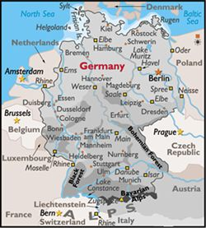](http://www.energyofanation.org/uploads/Alemaniamap.jpg)

**German Immigration to the United States**

**When were the major waves of immigrants from Germany to the United States?**

* Before the major waves of German immigration began, already 8.6% of the population was German.  Many had immigrated to Pennsylvania seeking religious freedom or had come under the redemptioner system.  German peasants would receive free passage to America but would be required to work for a businessman for 4-7 years to repay the cost of the voyage.
* 1850's - Nearly 1 million Germans immigrated to the United States.
* 1870's - 723,000 Germans immigrated to the United States.
* 1880's - 1,445,000 Germans immigrated to the United States.

**From which regions of Germany did they leave?**

* In the 1850's small farmers and their families left southwestern Germany.
* Soon after, artisans and manufacturers left the central states of Germany.
* Later waves were made up of day laborers and agricultural workers from the rural northeast.

**Push Factors**

* After the Napoleonic Wars ended in 1815 the German economy was suffering.  Foreign imports (especially cloth from England) flooded the German markets and German industry could not compete.  In addition inheritance tradition of dividing farms among families was making farms so small that they were unsuccessful.
* The population had grown very large and was dependent on the potato to sustain it.  In 1840 rural Germany was struck by the potato blight which led to famine.
* German princes sponsored societies (in the 1830's and 40's) that provided one way tickets to the poor with the idea that in the long run it was cheaper than long-term subsidies.
* A bestselling book in 1829 about Missouri by Gottfried Duden inspired a tidal wave of emigration.
* Social and economic discrimination in Germany led to the emigration of thousands of German Jews during all the immigration waves and Catholics after the May Laws of the 1870's.
* During several of the immigration waves, young men emigrated to escape being conscripted in the German (Prussian) military service.

**Pull Factors**

* Aid societies promoted immigration by supporting bettering the conditions of immigrants
* The north-central states (Wisconsin, Minnesota and Michegan) promoted their states for settlement among Germans with funding and support from their state legislatures.
* The transcontinental railroads sent agents to ports of departure and arrival to recruit immigrants to take up their land grants or ship their goods through their freight lines.
* Chain migration occurred during the later phases of German immigration as newcomers joined family and friends who had made the journey before them,

**Where did they settle, and why?**

* German Americans are most densely settled in the traditional "German belt" of Wisconsin, Minnesota, North Dakota, Nebraska and Iowa.
* One settlement pattern was named the "German triangle" from Saint Paul to St. Louis and Cincinnati incorporating other cities of German settlement: Chicago, Milwaukee, Indianapolis, Fort Wayne and Davenport.
* Germans had an important role in the cotton trade based in Louisiana so many arrived in New Orleans and made their way up the Mississippi, Ohio and Missouri rivers.
* Early German immigrants arrived in the port of Philadelphia and many chose to settle in Pennsylvania.
* Many who arrived in New York traveled the Erie Channel and the Great Lakes to the Midwest.
* The section on Pull factors will indicate other reasons why The German Belt consisted of the above mentioned states.

**Housing**

* Homeownership was valued highly among German immigrants and they purchased homes as soon as possible and preferred homes made of brick.

**Employment**

* Occupations dominated by Germans included baking, carpentry and brewing. They were also laborers, farmers, musicians and merchants.
* Many German immigrants had an agricultural background and also farmed in the United States.  The entire family (often large) worked the farm.
* Small family operated businesses were also common for German immigrants.
* Children left school at a young age.  Boys helped with the family business and girls worked as domestic servants.
* German women who were employed outside of the home, farm or family business did not tend to work in factories.  Rather they labored in janitorial or service industries.
* Their involvement in labor unions helped German immigrants achieve better working conditions and they formed networks with workers of other backgrounds.

**Assimilation**

* German immigrants assimilated more slowly than other immigrants due to their high numbers within the population.
* Also their basic needs - churches, schools, businesses, and stores - could be met within the German immigrant community.  Therefore interaction with the native-born community was not as urgent.

**Stereotypes, Discrimination, and Other Struggles**

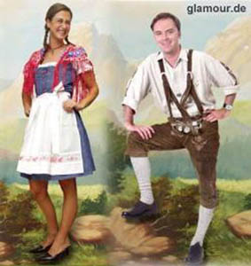

* The popular culture presents a sterotyped view of Germans as either brutal or jolly, overwheight and beer-guzzling.
* German culture is portrayed very narrowly and only represents one region of Germany - Bavaria where the capital Munich is located.  The typical traditional costume of that region is the lederhosen (short pants with suspenders) and dirndl (full skirt) which has come to symbolize all of Germany.

**Contributions to the United States**

* The German Christmas was the base for many of the American Christmas traditions including the giving of gifts, the Christmas tree and the emphasis on family.
* The labor movement was made strong by the particpation of many German immigrants.
* Albert Einstein, the prominent scientist in the field of physics and atomic energy in particular, was an immigrant from Germany.
* Babe Ruth and Lou Gehrig were both baseball legends and sons of German immigrants.

**Interesting Facts to Compare to Today's Immigration Debate**

* From 1850-1870 German was the most widely used language in the United States after English.
* Germans sought to maintain the German language through establishing German language schools.  In 1881 approximately 1 million children were attending schools with all or part of the curriculum taught in German .(42% of that total were being educated in the public school system.)

**Resources Used for this Report***Gale Encyclopedia of Multicultural America, 2nd edition.* Edited by Jeffrey Lehman. New York: Gale Group, 2000.

Here are some links to learn more about the Jews of Germany:

<http://en.wikipedia.org/wiki/Ashkenazi_Jews>

<http://en.wikipedia.org/wiki/German_Jews>

<http://www.jewishvirtuallibrary.org/jsource/vjw/germany.html>

<http://en.wikipedia.org/wiki/Timeline_of_Jewish_history>

<http://web.me.com/ebauer/translations/page4/page4.html>

|  |
| --- |
| <http://maggieblanck.com/NewYork/LowerEastSide.html>  <http://maggieblanck.com/Goehle/Germans.html> |

<http://maggieblanck.com/Goehle/Germans.html>

<http://maggieblanck.com/Goehle/Germans.html>

<http://www.energyofanation.org/4e667f77-e302-4c1a-9d2e-178a0ca31a32.html?NodeId>=

APPENDIX IV: The Precancel Stamp Society,

Early Precancel Device Manufacturers, by C. C. Fisher

<http://www.precancels.com/?page_id=492>

Research has been undertaken into the question of which manufacturers supplied the Post Office Department with precanceling devices. After many disappointments a file was found in the office of the Postmaster General which gave clues leading to a solution of the problem.

The first government contract for the supply of rubber handstamps specifically for precanceling stamps was dated June 15, 1915, and was with H. Baumgarten Company of Washington, D. C. The contract was for the twelve months of the fiscal year 1916. (A government fiscal years runs from July 1 through June 30 and is numbered for the calendar year containing the January-June dates.)

J. Baumgarten of Washingaon, D. C., was the contractor for FY 1917. E. (for Emmanuel, the founder of the firm) Baumgarten was the successful bidder for fiscal years 1918 through 1921. He was succeeded by J. Baumgarten & Sons, Inc., for one year, followed by J. Baumgarten & Sons Co., Inc., for fiscal years 1923 and 1924.

Henry Moss & Co., Brooklyn, N. Y., received the contract for rubber precanceling handstamps in June 1924 for the next two fiscal years. Then the business was brought back to Washington by the Baumgarten Company of Washington, who appeared as successful bidders for the fiscal years 1927, 1928, 1929 and 1930. No contract was found for FY 1931, but other information indicates that Baumgarten continued as contractor. Cooper Stamp Works, New York, N. Y., received the contract for FY 1932, which was the last contract for rubber precanceling devices until 1959.

Chambers, of Lodge, Va., developed the metal handstamps and was the successful bidder beginning in July 1932 and continuing through June of 1958. It is understood that there were change’s in the corporate set-up of the company, with resulting changes of name, but all the handelectros were manufactured in the same plant.

Baumgarten, now known only as Baumgarten Company, was sold to Edgar R. Baturin, Melvin M. Gusdorf, and Melvin M. Gusdorf, Jr., during this period. The new owners (not related in any way to the founders) developed a neoprene rubber handstamp which was impervious to the oil-based inks which had ruined other types of rubber devices and caused the Department to switch to metal precanceling handstamps. Because of this devel opment, with attendant lower prices, they became the official contractors for FY’s 1959 and 1960.

A lower bid was submitted by Hanley Postal Supply, Erie, Pa., in the early summer of 1960; this firm is the current contractor.

And now, a few words about the various Baumgarten contractors. There must have been several brothers and at least one of more distant relationship. All of them operated in Washington except one, who did his bidding from Baltimore, Md., but delivered his product from Washington. It is said that at one time there were two different plants, both in Washington, and both specializing in rubber stamps.

In the above recital of handstamp contractors there was no mention of the period from July 1, 1913, when the Post Office Department first began to issue precanceling devices to postmasters, to July 1, 1915. Prior to 1915 rubber precanceling handstamps were not listed as items of issue in department supply catalogs. Items 500, 501 and 502 were various types of rubber handstamps, including one on which the price was per square inch, as ordered. This item could have been “for precanceling postage stamps” but was not so specifically designated. In 1915 Item 503 was added to the list of available supplies, and this item was specifically designated “For Precanceling.” Actually the item number, or the lack of it, makes Little difference historically because the contractor during this period was: Baumgarten!

Rubber precanceling handstamps were first designated as Item 503. In 1932 (when the change was made to hand electrotypes) the designation was changed to Item 762, but when the change was made back to rubber handstamps in the middle of 1958 no change was made in the item number.

Item 780 is an electrotype plate, properly backed and mounted, issued to postmasters for precanceling 2500 sheets (or more) of stamps by letterpress printing. It first appeared in the bids for 1918, but no award was made that year, or in 1919 or 1920. First successful bidder on this item was Franklin Bauer Company, New York, N. Y., who provided electros to the department for the fiscal years’ 1922, 1923 and 1924. No record of award was found for FY 1925, but United Electrotype Company, Nashville, Tenn., held the contract for fiscal years 1926 through 1929, when they were underbid by Potomac Electrotype Co., Inc., of Washington, D. C., who has continued to date.

No contract awards for electrotype plates we’re made prior to the spring of 1921. Under the system employed by the Post Office Department when an award is not made the current contractor continues to perform. It became necessary to discover who this earliest contractor was, in order to complete the record.

Turned out to be the Government Printing Office, which set the type for and produced the first electro type precanceling plates. Although no formal reference to this arrangement remains in department files the information was confirmed by some of the older retired employees of the Government Printing Office.

For the one missing year (FY 1925) the contractor could have been either Franklin Bauer Company or United Electrotype Company. Present inconclusive information seems to favor Bauer.

DLEs were the work of Potomac Electrotype Co. Specifications at that time called for a “double line border,” but both the electro manufacturer and the rubber handstamp manufacturer took this to mean thin double lines above the city and below the state names.

APPENDIX V: Interview with Nathan Moss, June 20, 2012

Met with Nathan Moss and his daughter Bettina Moss at the Clove Lakes Rehab Center <http://clovelakes.com/> on Staten Island. Nathan begins by telling me that he had received a number of patents over the years, his IQ was tested at 160. He had polio at age 4, graduated high school at 16, had gotten into Yale and Bucknell, went to Bucknell and graduated in three years, at 19. But then his father passed away (~1949) and he went into business with his older brother George. George was a Yale Law School graduate who enjoyed selling, and Nathan was an engineer. They produced marking devices: nameplates, signs, etc. He even invented a tag that could withstand the heat of a crematory so that the ashes of one person would not be confused with another’s.

He was married to his first wife for fifteen years.

He was told that his Grandfather Benjamin Moss (George’s father; Robertina’s husband) had come from England in the 1820’s. His father Benjamin Franklin Moss told him that he had grown up on the Lower East Side of Manhattan.

His children are: Selma (RI), Bettina (LA), Michelle (SI), Grace (Mineola), Ben (LA), and Janine (a model, she’s all over)…

His brother George’s children are: Floyd (deceased; did drugs, then Chabad); Jonny (a pilot in NJ), and Brett (MD)

Nathan says that his father Benjamin Franklin Moss had bought Henry Moss out.

He knew Ira and Sandy; does not remember ever meeting Marcia.

His mother was Grace Szerlip. Grace had three brothers: Lothair, Sidney, and Arthur. Lothair was an attorney. Arthur was a retired police officer (he was the first Jewish policeman in NYC, 1904). Nathan was named for his grandfather Nathan Szerlip: He’s Nathan Szerlip Moss. Lothair got them to do WWII ship marking, which was very profitable.

There was a story that the family had hidden money in a mausoleum. People thought they were very attentive to visit. No, Nathan said. He had heard the same rumor, but it was only a rumor. In fact, Lothair had been hiding money at his estate in Monroe. I had heard Lothair had been in jail. No, Nathan said. But his brother Sidney, the attorney, had been disbarred (for a while). He had “fudged” something regarding an inheritance. What about the story that his brother George had been in jail. That was true, he said. He went away when he was in his 40’s or 50’s for tax evasion. The government had put his business in bankruptcy, and then he was found to have taken equipment out. (No, Bettina said. What George went away for was for forging checks; it may have had to do with tax evasion.)

Where was this infamous mausoleum? It’s in Acosia [Acasia?] Cemetery in Queens. It’s the Szerlip Mausoleum. Benjamin Franklin Moss and Grace Szerlip Moss are buried there. Lothair tended to it; he died around 1992. The cemetery went bankrupt, was abandoned, and has now been taken over. Lothair’s daughter Johanna has the key, and there is bad feeling about the way she has taken control; the Moss’s cannot get in.

BF Moss bought the mansion on Ocean Avenue in 1930. It had a Billiard Room/Library, a “Playroom” and a room for the servant to sleep in.

Grandfather Szerlip had a scrap metal business.

The factory had been on 53rd Street between 1st and 2nd Avenues in Bklyn. Henry Moss and Co had moved there from NYC. Henry Moss & Co and the Moss brothers business shared a location.

# APPENDIX VI: Holocuast Soldiers

# The Weekly Standard

# Holocaust Soldiers

## In February 1945, the Nazis classified 350 American POWs as Jews. PBS's documentary "Berga: Soldiers of Another War" sheds light on the nightmare that followed.

12:00 AM, May 28, 2003 • By [VICTORINO MATUS](http://www.weeklystandard.com/author/victorino-matus)

NOT THAT WE BASE OUR IMPRESSIONS on life in a German POW camp entirely on "Hogan's Heroes," but there is an understanding that life in a stalag wasn't nearly as bad as life, say, under the Japanese. Roughly 4 percent of Americans died in German and Italian camps while a staggering 27 percent died in Japanese camps. In Western Europe, Allied prisoners (except the Russians) enjoyed certain benefits thanks to the Geneva Convention. They received Red Cross parcels, enough food, and were often allowed to exercise and play soccer. It wasn't the Waldorf-Astoria, but it wasn't Auschwitz either. At least for most of them.

With the Allies closing in on the Reich, the stalags began to swell. By 1944, Stalag 9B, northeast of Frankfurt, held 10,000 Red Army prisoners. Following the Battle of the Bulge in December of that year, an additional 4,000 Americans filled the camp. As SS interrogators took down the names, ranks, and serial numbers of the newly arrived, they happened to notice a sizable number of Jewish-sounding names. It was only a matter of time before the Germans demanded to know which of these 4,000 American POWs were Jews.

"In our country, we don't differentiate by religion--we are all Americans," said Hans Kasten, a POW designated as an intermediary for the two sides. His answer was apparently incorrect--after giving it he was thrown down a flight of stairs. Kasten went back to his men and instructed them that under no circumstance is anyone to admit who among them is Jewish. At the next day's lineup, not a single POW responded to the SS officer's request for all Jews to step forward. Enraged, the Germans decided to make the selection themselves, based on which names sounded Jewish and who looked Jewish. In the end, 350 men were separated, unaware of the horrors to come.

Acclaimed documentary filmmaker Charles Guggenheim served in the 106th Division--elements of which were captured after the Bulge. Himself a Jew, Guggenheim could have easily been one of those 350 men if not for a serious case of blood poisoning, that caused him to miss his deployment to Europe. When he finally met up with members of his unit, he asked what had happened to a Jewish friend of his. To his shock, Guggenheim was told he died in a salt mine. His friend was one of those labeled "undesirable" and shipped off to Berga, a satellite camp of Buchenwald in eastern Germany. His fate was a constant source of pain for Guggenheim and it led him to make a documentary, "Berga: Soldiers of Another War," which airs tonight at 8:00 p.m. on PBS.

Interviewed by historian David McCullough last fall, Guggenheim talked about the need to do this film. "This was the first time Americans who spoke like I did, who looked like I did, who grew up in the same country as I did, were part of something that I never comprehended as being close to me. And I decided to do a film about this thing that was done to Americans--not only Americans, but American soldiers." Guggenheim shot on location in the town of Berga and combined first-hand accounts along with stark photographs of the camp's victims from April 1945. It was to be Guggenheim's final film--he died of pancreatic cancer six weeks after its completion. "Berga" is a powerful examination of the limits of humanity--both the ability to do evil and the will to survive. (And if there is any justice, Guggenheim should posthumously receive his fifth Academy Award for this work.)

Not everyone aboard the train to Berga knew what was coming. Some had no idea they would be persecuted at all because of their religion. One man remembers when the harsh reality dawned on him as a fellow soldier made clear, "Germany doesn't like Jews. And they're going to do something to us." "The only thing I could think was, I shouldn't have told them I was Jewish," says another. But their dog tags were dead giveaways, as one POW explains: "If your name was Greenberg or Goldberg, what chance did you have?"

Yet the Germans couldn't quite make the differentiation themselves, choosing men with names like "Watkins," "Acevedo," "Young," and "Griffin," too. In fact, of the 350 Americans sent to Berga, only 80 were actually Jewish. Hans Kasten, the leader who refused to name names, was among them and faced even worse treatment since he was a German-American. As an SS lieutenant told him, "the one thing worse than a Jew is a German traitor."

Berga already existed when the new prisoners entered in February 1945. The camp's inmates were to dig 17 tunnels underground in order to construct an armaments factory safe from Allied bombing. The arrival also marked the first time these Americans witnessed the Holocaust with their own eyes.

Conditions at the camp were horrific. The prisoners were two per mattress, four in a bunk. They were never allowed to change clothes. Lice was rampant. There was dysentery and typhoid. Daily nourishment consisted of watery soup and one loaf of bread divided among twelve men. They quickly learned to eat slow, chew slow, "make it last." The POWs spent 12 hours a day in the quartz mines, which, according to one man, was worse than coal mines: "Coal dust can make your lungs black. But it doesn't rip your lungs out. Quartz, you breathe it in and then spit it out and a piece of your lung comes out. It was bloody. Quartz rips your lungs apart."

All told, some 70 Americans died during the course of two months at Berga. Those who survived would never be the same. "We became shadows of ourselves," says one. Leo Zaccaria remembers how he refused to give up his knife for days after being liberated. "I was an entirely different person. I had become an animal." Hans Kasten's first thought was to find the SS lieutenant who tormented him. He never found the officer but says, "I would have killed him . . . slowly." Still others fell to tears when at last they spotted American tanks. Says Sanford Lubinsky: "When I saw that American flag coming down that road, nothing looked so beautiful in all our born days. It's a very beautiful thing when you haven't seen it for a long while."

"Berga: Soldiers of Another War" airs Wednesday night at 8 p.m. on PBS.

Victorino Matus is an assistant managing editor at The Weekly Standard.

APPENDIX VII: PAUL/PAULA GROSSMAN

Born Paul Monroe Grossman, this cousin – born in 1919, married to Ruth, with twin daughters Carol and Claire born in 1958 – was a music teacher at Cedar Hill Elementary School in Basking Ridge, NJ who in 1971 underwent one of the first sex-change operations in the United States. Paula Miriam Grossman of Plainfield, NJ dies in 2003.

Wikipedia contains the following:

“Also in 1976, the New Jersey Supreme Court rejected the appeal of a transgender plaintiff, Paula Grossman, in a sex discrimination case involving termination from her teaching job after sex reassignment surgery”

<http://en.wikipedia.org/wiki/Transgender_American_history#cite_note-20>

The story was covered on television news, with David Brinkley reporting: Supreme Court rejects plaintiff's appeal in sex discrimination case involving New Jersey school system. Paula Grossman, formerly Paul, was fired from teaching job after sex-change operation.   
REPORTER: David Brinkley. See ["Supreme Court / Sex Discrimination Case / New Jersey Teacher NBC News broadcast from the Vanderbilt Television News Archive"](http://tvnews.vanderbilt.edu/program.pl?ID=485785). Tvnews.vanderbilt.edu. 1976-10-18. Retrieved 2012-05-15. <http://tvnews.vanderbilt.edu/program.pl?ID=485785>